Role Profile

Job Description

This post will be subject to an enhanced DBS check and there is an Occupational Requirement under the Equality Act 2010 Schedule 9 (Part 1) for the post holder to be a woman.
Job Title | Data Officer
Salary | £27,063 pro rata actual 16,238
Responsible To | Impact and Performance Manager
Hours | 21 hours per week over 4 or 5 days

Leeds Women’s Aid (LWA) is the largest women’s charity in Leeds, and has been providing support to women and children affected by Domestic Violence and Abuse (DV & A) for 50 years. We are committed to our values and strive to embody them in everything we do. We provide a range of the very best services for vulnerable women and families who are victims and survivors of: domestic, sexual & honour- based violence and abuse; forced marriage; trafficking; stalking and harassment.

LWA is the lead agency for commissioned Leeds Domestic Violence Service (LDVS), a consortium of 3 agencies offering support to women, men and transgender/non-binary people. This service works within a multi-agency framework provides high quality, pro-active service to victims of domestic, sexual and honour- based violence and abuse, stalking and forced marriage, often those at the highest risk.

LWA is also the lead agency in the innovative and unique National Lottery Community Fund Funded Women’s Lives Leeds (WLL) Alliance, consisting of 12 women’s and girls’ organisations. Working with vulnerable women and girls, our vision is that many more women and girls in Leeds will have their needs met and be empowered to lead safer and healthier lives.

Purpose of Job

To provide high quality administrative and monitoring support. This post holder will be responsible for preparation and completion of internal & external monitoring requirements, and following appropriate GDPR measures.

Physical Conditions

This post can be undertaken on a hybrid working schedule, with some days home-working and some days working in the LWA main office.

Economic Conditions

This is a part-time post with a salary of £27,063 pro rata.

Responsibilities

Responsible to:
Impact and Performance Manager (IPM)
All paid members of staff are accountable to the Chief Executive, and ultimately the Trustees of Leeds Women’s Aid, and will work according to policies and procedures agreed by them.

Main Duties

- Data quality checks and interrogation – linking in with IPM and other managers or TL’s as appropriate to improve recording on the case management system Oasis On Track (OT)
- Complete quarterly Public Health Workbook & associated reports
- Complete 6-monthly Ministry of Justice (MOJ) workbooks and co-ordinate any additional narrative or financial information
- Assist with the annual Ministry of Housing Communities and Local Government (MHCLG) monitoring
- Deal with any other ad-hoc monitoring requests
- Complete monthly summary figures and weekly Helpline/Referral figures
- Work closely with the IPM and CEO in the preparation of Impact Reports
- Prepare summary information for individual teams to be shared via TL meetings or other relevant team meetings
- Assist the IPM with preparing updates for meetings as required
- Attend other team meetings and report key figures/changes
- Be a Key Contact for LDVS case management system – Oasis On Track (OT)
  - Set up/removal of users with the correct permissions
  - Deal with any general OT queries; including password reset, remote access
  - Set up standard reports as required
  - Provide training and support to staff as required
- Monitor and deal with emails received to the CJSM Admin account
  - Any other general emails received to the account
  - General housekeeping of the account – e.g. password/storage level
- Assist the IPM with Subject Access Requests
- Provide general administrative support to LDVS & LWA as required
  - Office cover – phones/visitors/deliveries
  - Other ad-hoc general requests

General

- Attend staff meetings and other training events as required.
- Assist staff with IT issues e.g. Oasis platform
- To uphold LWA's policies, with particular reference to confidentiality, health and safety and equity, diversity and inclusion.
- To carry out any other duties or training commensurate with the post.
- To carry out any other duties that are reasonably required by LWA

Person Specification

Our ideal candidate will be able to demonstrate

Experience | How Assessed:  C = Covering Letter  I = Interview
- Use of Microsoft Excel, Office and excellent IT skills | C & I
- Working under pressure and meeting strict deadlines | C
- Use of case management system & monitoring databases | C & I
- Running reports and completion of funders’ monitoring workbooks | I
- Working in the Third Sector | C
- Experience using Canva or Publisher or other similar software | I
- Producing reports and information for internal and external partners | C & I
- Preparing regular and ad-hoc statistics | C & I

Understanding | How Assessed:  C = Covering Letter  I = Interview
- Working collaboratively with colleagues and partner organisations | I
- An understanding of domestic violence & abuse | I
- Importance of data protection and recording accurate information | C & I

Skills | How Assessed:  C = Covering Letter  I = Interview
- Excellent IT skills, including Outlook, Excel, Word, Teams | I
- Excellent organisational skills | C & I
- Flexibility and ability to work to very tight deadlines | C
- Ability to work under own initiative, prioritise work and handle pressure | I
- Excellent attention to detail | C & I
- Ability to communicate effectively at all levels | C & I
- Excellent interpersonal & communication skills | I

Professional Qualification | How Assessed:  C = Covering Letter  I = Interview
- n/a

Personal Qualities & Competencies | How Assessed:  C = Covering Letter  I = Interview
- Willingness to work within LWA’s values | C & I
- Willingness to work within the principles and policies of LWA and its associated projects | C
- Commitment to working in a manner which is empowering and supportive | C & I
- Commitment to working in non-discriminatory manner | C
- Willingness to work occasional unsocial hours | C
- Continuous personal development to extend | C
- Committed team player and willing to support colleagues within the team and wider organisation | I

LWA’s Values

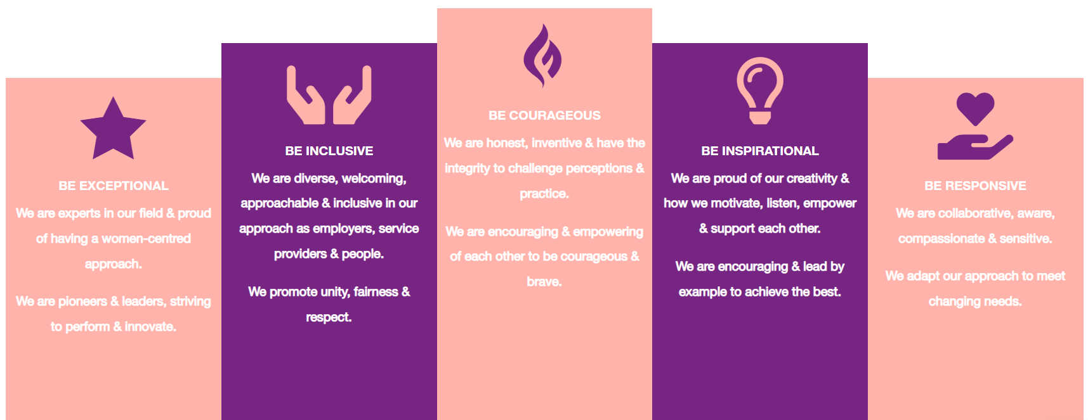

1. Be Exceptional
• We are experts in our field & proud of having a women-centred approach
• We are pioneers & leaders, striving to perform & innovate

2. Be Courageous
• We are honest, inventive & have the integrity to challenge perceptions & practice
• We are encouraging & empowering of each other to be courageous & brave

3. Be Inclusive
• We are diverse, welcoming, approachable & inclusive in as employers, service providers & people
• We promote unity, fairness & respect

4. Be Inspirational
• We are proud of our creativity & how we motivate, listen, empower & support each other
• We are encouraging & lead by example to achieve the best

5. Be Responsive
• We are collaborative, aware, compassionate & sensitive
• We adapt our approach to meet changing needs

