Role Profile

Job Description

Job Title | Children & Young People’s Domestic Violence Worker - Female*
Salary | £20,640 per annum
Responsible to | Children & Young People’s Team Leader & Operations Manager (Refuge)
Hours | Term Time at 35 hours for 39 weeks per year
Contract | Permanent

This post will be subject to an enhanced DBS check and there is an Occupational Requirement under the Equality Act 2010 Schedule 9 (Part 1) for the post holder to be a woman.

Leeds Women’s Aid (LWA) is the largest women’s charity in Leeds, and has been providing support to women and children affected by Domestic Violence and Abuse (DV & A) for over 50 years. We are committed to our values and strive to embody them in everything we do. We provide a range of the very best services for vulnerable women and families who are victims and survivors of domestic, sexual & honour-based violence and abuse, forced marriage, trafficking, stalking and harassment.

LWA is the lead agency for Leeds Domestic Violence Service (LDVS), a consortium of 3 agencies offering support to women, men and transgender/non-binary people. This service works within a multi-agency framework and provides high quality, pro-active service to victims of domestic, sexual and honour-based violence and abuse, stalking and forced marriage, often those at the highest risk.

LWA is a member of the unique Women & Girls Alliance – Leeds, consisting of 12 women’s and girls’ organisations. Working with vulnerable women and girls, our vision is that many more women and girls in Leeds will have their needs met and be empowered to lead safer and healthier lives.

Purpose of Job
ELEVATE is a specialist Children and Young People (CYP) community service delivered in partnership with schools across Leeds.
As a CYP Domestic Violence, you will:
- Deliver specialist interventions and support to children and young people affected by domestic and sexual violence
- Provide advocacy, emotional support, and practical guidance within a school setting
- Work collaboratively with families, schools and partner agencies to improve outcomes and ensure safety
You will take a trauma-informed, child-centred approach, ensuring each young person’s needs are understood and addressed through tailored support.
Leeds Women’s Aid provide safe, emergency refuge accommodation for individuals and families who are fleeing domestic violence and abuse. The ELEVATE team work closely with the wider refuge teams; working as part of a co-ordinated community response, applying specialist knowledge and skills in a variety of contexts to provide advocacy and support to ensure safety, wellbeing and recovery. You will carry out risk and needs assessments and undertake safety planning with victim-survivors and work within a multi-agency framework to ensure the safety of CYP, is prioritised.

Physical Conditions

The post will be based in our main refuge located within Leeds. You will also travel to other sites, including schools to offer services to CYP within the community.

The postholder will be required to hold a full driving licence and have access to a vehicle with business insurance.

Economic Conditions

Term Time at 35 hours for 39 weeks per year, £20,640 per annum

Responsibilities

Responsible to: Children and Young People’s Team Leader
All paid members of staff are accountable to the Chief Executive, and ultimately the Trustees of Leeds Women’s Aid, and will work according to policies and procedures agreed by them.

And close liaison with: Leeds Women’s Aid (LWA) and Leeds Domestic Violence Service (LDVS) Refuge services.
*Occupational Requirement – female
This post is restricted to female applicants under Schedule 9, Part 1 of the Equality Act 2010.
This requirement is applied lawfully and proportionately, reflecting the organisation’s provision of specialist women-led and women-centred services and the need to maintain safety, trust and authenticity in leadership and external representation.
In addition, the role involves direct professional involvement in safeguarding, domestic abuse practice oversight and regular engagement with women affected by male violence and abuse, for whom access to a female professional is necessary to ensure safety, dignity and effective engagement.

Main Duties

- Explore the emotional and practical needs of Children and Young People to support and help them to respond to risk and/or recover.
- Build trusting professional relationships with victim-survivors of domestic violence and abuse, providing specialist support via planned sessions, completing person-centred support plans, carry out risk assessments, safeguarding and safety planning.
- Develop a thorough understanding of a child’s life and history to provide effective needs-led support.
- Engage with Children and young people victim-survivors from marginalised and disadvantaged groups and diverse social backgrounds in ways that respond to their individual identities.
- Provide support which is appropriate to age, developmental stage, cultural background and SEND needs. Support and safety planning will be needs-led, tailored to the individual with a Children’s Rights-based approach, culturally sensitive, responsive and inclusive ensuring CYP voices are heard and validated.
- Refer and signpost to other relevant voluntary or statutory multi-agency partners. Establish and maintain effective collaborative working relationships with key agencies e.g. education providers, social care, health providers, courts etc, so that the needs of Children and young people are met appropriately.
- Act as an independent advocate for children and young people
- Where safe to do so, work with the protective parents with the support of schools or social care. Signposting to other parts of LDVS services or external agencies where applicable, to assist with parenting and family support.
- Where required, support victim-survivors through police investigations and/or court processes within the context of own role.
- Completion of Young People’s DASH Risk Checklist and involvement in MARAC and/or DRAM.
- Be adaptable, using age-specific activities, games and tools in a therapeutic space to help explore difficult topics.
- Safeguarding is prioritised in a timely response and adhered to in accordance with Leeds Women’s Aid’s Safeguarding policies and Leeds local safeguarding protocols.
- Lone working: work with Children and Young people within the community on an individual basis.
- To work with other Leeds Women’s Aid and LDVS colleagues where appropriate, to provide holistic interventions of care for families experiencing domestic violence and abuse, or sexual violence.
- To have a Trauma informed practice and approach.
- Reflect on own practice and access available supervision and case management support provided.
- Maintain own continuous professional development and revise practise based on feedback received.

General

- Attend staff meetings and other training events as required.
- To uphold Leeds Women’s Aids policies, with particular reference to confidentiality, health and safety and equity, diversity and inclusion.
- Assist and promote the empowerment of survivors of domestic violence and abuse or sexual violence who may have experienced inequality, discrimination and/or forms of injustice.
- To carry out any other duties or training commensurate with the post.
- To carry out any other duties that are reasonably required by Leeds Women’s Aid.

Person Specification

We welcome applications from people who bring most of the following and who can demonstrate alignment with our values and commitment to women-centred practice. We do not expect you to meet every element of this profile.

Experience | How Assessed:  A = Application Letter  I = Interview
- Experience supporting children and young people affected by trauma | AI
- Knowledge of safeguarding legislation and practice | AI
- Understanding of domestic and sexual violence, including coercive control and honour-based abuse | AI
- Awareness of the impact of abuse on victim-survivors | AI
- Experience of working with diverse communities | AI
- Experience of working within a multi-agency framework and knowledge of Leeds based services is desirable. | AI
- Experience of managing caseloads, risk assessments, and support planning. | AI
- Experience of contributing to reports for social care or similar (desirable) | AI
- Experience of trauma informed practice

Understanding
- Desirable understanding of how to deliver group activities or Children and Young people’s programmes. | AI
- Tailoring age-appropriate support to children and young people. | I
- Knowledge and understanding of vulnerable children and young people’s needs, emotions and behaviours. | I
- Knowledge and understanding of a whole family approach | I
- Knowledge of Child Development Stages | I

Skills
- Strong interpersonal and communication skills | AI
- Ability to build trust while maintaining professional boundaries | I
- Advocacy skills, enabling Children and Young people to express their views and make decisions | AI
- Staying present with an empathetic approach when Children and young people become dysregulated | AI
- Recognise crisis situations and respond within the required timescales in line with organisational policies | AI
- Time management and organisational skills working on own initiative | I
- Lone working | I
- Effectively working with a multi-agency approach to ensure the best outcomes for the children and young people or family is met. | AI
- Confident in managing a high case load & understanding the importance of case recording: we use a range of technology and systems | I
- Hold a full driving licence and have access to a car. | A
Personal Qualities & Competencies
- Values must be consistent with those of LWA. | AI
- Be caring and compassionate. | I
- Be non-discriminating, anti-oppressive and anti-racist. | AI
- Be survivor-centred. | AI
- Be reliable and committed. | I
- We work with people at risk with an expectation that we work in a way that protects from further harm. | AI
- Ability to maintain confidentiality. | AI

LWA’s Values

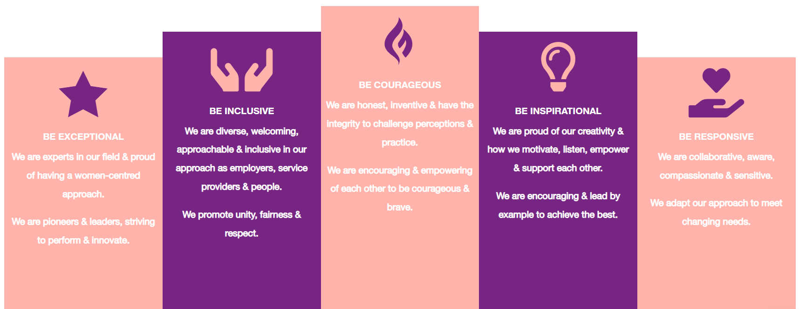

1. Be Exceptional
• We are experts in our field & proud of having a women-centred approach
• We are pioneers & leaders, striving to perform & innovate

2. Be Courageous
• We are honest, inventive & have the integrity to challenge perceptions & practice
• We are encouraging & empowering of each other to be courageous & brave

3. Be Inclusive
• We are diverse, welcoming, approachable & inclusive in as employers, service providers & people
• We promote unity, fairness & respect

4. Be Inspirational
• We are proud of our creativity & how we motivate, listen, empower & support each other
• We are encouraging & lead by example to achieve the best

5. Be Responsive
• We are collaborative, aware, compassionate & sensitive
• We adapt our approach to meet changing needs

