Role Profile

Job Description

Job Title | Children and Young People’s Domestic Violence Worker (Elevate Service) - Female*
Salary | FTE £26,451 per annum
Responsible to | Children and Young People’s Team Leader and Operations Manager
Hours | Two posts 35 Hours - £26,451  21 Hours - £15,877
Contract | Temporary contract for 12 months from 1st April 2025

This post will be subject to an enhanced DBS check and there is an Occupational Requirement under the Equality Act 2010 Schedule 9 (Part 1) for the post holder to be a woman.

Leeds Women’s Aid (LWA) is the largest women’s charity in Leeds, and has been providing support to women and children affected by Domestic Violence and Abuse (DV & A) for over 45 years. We are committed to our values and strive to embody them in everything we do. We provide a range of the very best services for vulnerable women and families who are victims and survivors of domestic, sexual & honour-based violence and abuse, forced marriage, trafficking, stalking and harassment.

LWA is the lead agency for Leeds Domestic Violence Service (LDVS), a consortium of 3 agencies offering support to women, men and transgender/non-binary people. This service works within a multi-agency framework and provides high quality, pro-active service to victims of domestic, sexual and honour-based violence and abuse, stalking and forced marriage, often those at the highest risk.

LWA is a member of the unique Women & Girls Alliance – Leeds, consisting of 11 women’s and girls’ organisations. Working with vulnerable women and girls, our vision is that many more women and girls in Leeds will have their needs met and be empowered to lead safer and healthier lives.

Our Values
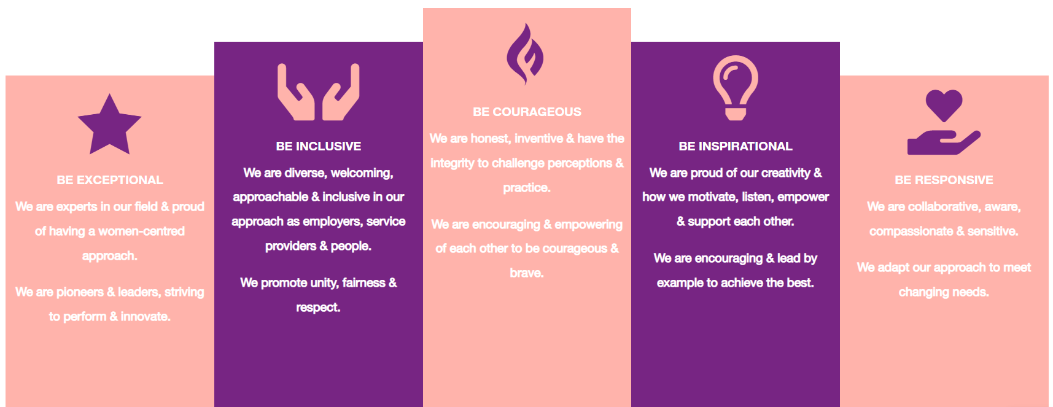

1. Be Exceptional
• We are experts in our field & proud of having a women-centred approach.
• We are pioneers & leaders, striving to perform & innovate.

2. Be Courageous
• We are honest, inventive & have the integrity to challenge perceptions & practice.
• We are encouraging & empowering of each other to be courageous & brave.

3. Be Inclusive
• We are diverse, welcoming, approachable & inclusive in as employers, service providers & people.
• We promote unity, fairness & respect.

4. Be Inspirational
• We are proud of our creativity & how we motivate, listen, empower & support each other.
• We are encouraging & lead by example to achieve the best.

5. Be Responsive
• We are collaborative, aware, compassionate & sensitive.
• We adapt our approach to meet changing needs.

Purpose of Job
There is good evidence that domestic abuse and violence can affect children’s psychological, physical, educational, and social well-being and that the impact of such trauma can continue long after the abuse has stopped. There is also increasing evidence that, with appropriate support, children can overcome the trauma of abuse and build healthy futures.
The purpose of this role will be as part of the ‘Elevate’ Service to identify, assess and plan to meet the needs of Children and Young People (CYP) in the community who have experienced / witnessed domestic violence and abuse, recognising CYP as victims in their own right. Support and Interventions include but is not limited; identifying child development, educational needs, safeguarding, advocating for the CYP and therapeutic interventions. The post holder will ensure that the child’s needs are being met by working collaboratively with parents, schools and other agencies to ensure the best outcomes for the child.

About Our ELEVATE Children and Young People (CYP) Community Service

ELEVATE is a Children and Young People’s Service based around education / schools within Leeds. The team is made up of two dedicated Domestic Violence Practitioners who work to support children and young people who have experienced domestic violence and abuse to help in recovery and with trauma. This abuse can include but is not limited to; coercive control, psychological and/or emotional abuse, financial or economic abuse, harassment/stalking and online/digital abuse. Children affected by domestic violence will be automatically treated as victims regardless of whether they were present during incidents.

We offer safe emergency refuge accommodation for individuals and families who are homeless as a result of Domestic Violence and Abuse (DV&A). We can support people from Leeds or elsewhere in the UK in our accommodation. We have women-only refuges, but we also have dispersed properties suitable for people of all genders. The ELEVATE team are also part of our wider Children and Young People Team who are based at refuge.

Our specialist Refuge Children and Young People Workers provide support to the children and young people to help them overcome the trauma of witnessing or experiencing domestic abuse. The team offers one-to-one support, group play, wellbeing sessions, as well as family groups such as a weekly Nurture Group, After-School Club and the Women’s Aid ‘You and Me, Mum’ programme.

Physical Conditions

The posts will be based at our office in Leeds. The post holder will also have to travel to other sites and locations in Leeds to offer services to families in the community.

Economic Conditions

We are recruiting two posts: 35 hours (5 days) and 21 hours (3 days) per week.

Responsibilities

Responsible to:
- Children and Young People’s Team Leader
All paid members of staff are accountable to the Chief Executive, and ultimately the Trustees of Leeds Women’s Aid, and will work according to policies and procedures agreed by them.

Main Duties

- Building trusting relationships with victims/survivors of domestic abuse; providing specialist support via key working sessions; completing person-centred support plans and risk assessments.
- Advocating for the child through liaising with and referring to other agencies.
- Developing a thorough understanding of a child’s life and history to provide effective needs-led support and interventions.
- Manage a caseload whilst undertaking assessments to implement safe and appropriate age-related Support Planning, Safety Plans and Risk Management; ensuring safety and respect of all CYP.
- Support is appropriate to age, developmental stage, gender, cultural background and any SEND needs. Support Planning will consider various factors incl. needs-led, tailored risk management, rights-based lens with cultural sensitivity, responsive and validating CYP voices.
- Be adaptable and flexible, using enjoyable CYP age-specific activities, games and tools in a therapeutic space to help explore difficult topics and help CYP process difficult emotions.
- Collaborate with CYP, Parents, Schools and agencies in a trauma-informed way.
- To work with other parts of our services where appropriate to provide holistic packages of care for families with clear lines of accountability and information sharing when working together to support a family.
- To establish and maintain effective collaborative working relationships with key agencies e.g. Education, Early Help Hubs, Children’s Centres, Health Visitors, CSWS, Intensive family Support etc, so that the needs of children in the community are met by the relevant statutory and voluntary agencies.
- To ensure safeguarding is paramount and adhered by in accordance with LWA’s Safeguarding Children and Young People Policy and the Leeds Safeguarding Children Partnership procedures.
- Often contributing to CYP monitoring, reports and statements to meet with statutory partners or health services and signposting to seek necessary legal advice or interventions i.e. Protection Orders as an example.
- To assist related adults to access appropriate services including other parts of LWA and LDVS services to assist with parenting and family support in the community.

General

- Attend staff meetings and other training events as required.
- To uphold LWA's policies, with particular reference to confidentiality, health and safety and equity, diversity and inclusion.
- To carry out any other duties or training commensurate with the post.
- To carry out any other duties that are reasonably required by LWA.

Person Specification
Our ideal candidate will be able to demonstrate

Experience | How Assessed:  A = Application Letter  I = Interview
- Clear knowledge, understanding of violence against women and girls. Domestic violence and abuse, sexual violence, Honour-based violence, Stalking, Forced Marriage; impacts on victim-survivors and legislation frameworks. | AL/I
- Clear knowledge and understanding of the impacts and trauma on victim survivors (for adults and CYP) | AL/I
- Clear knowledge of safeguarding legislation and practice for adults and CYP. | AL/I
- Trauma informed & compassionate approaches, with a good understanding of the impact on victim-survivors and children. | I
- Managing a caseload, implementing support plans, safety plans, risk assessments; in accordance to policies and procedures. | AL/I
- Provide and arrange practical assistance for CYP where necessary, including advocacy and liaison with other agencies and updating and making information accessible. | AL/I
- Tailoring age appropriate support plans and appropriate therapeutic activities to Children and Young People. | I

Understanding

- Support Children and Young People to have a voice and make their own decisions. | I
- Presenting options to allow Children and Young People to have choice and control over what happens in sessions, tailoring the approach to each child’s comfort level and interests. | I
- Staying present and calm when children become ‘dysregulated’. | I
- Knowledge of vulnerable children and young people’s needs and understanding their emotions and behaviours. | AL/I
- Signs and symptoms of abuse and neglect. Understanding of the ‘whole family approach’ and ‘asset-based’ ways of working. | AL/I
- Understanding of services across Leeds to support vulnerable Children and Young People. | AL/I
- Stages of Child Development. | I
- Understanding of Professional Curiosity. | AL/I
- Contribute to the completion of reports for Children’s Social Care Conferences and meetings regarding the families. | AL/I
- If appointed, you will be expected to update your knowledge on Health & Safety and Lone Working Procedures. | I

Skills

- Excellent time management and organisational skills working on own initiative and within a multi-disciplinary team. | AL/I
- Building effective relationships, developing and encouraging partnership working through advocacy. | I
- Have excellent interpersonal and communication skills. | AL/I
- The ability to work in multi-agency teams to ensure you get the best outcome for the child/family. | I
- We use a range of technology systems and expect colleagues to use them effectively and safely, following cyber security and data protection principals/GDPR. | I

Professional Qualification

- Holds a Children and/or Young Peoples qualification. e.g. NVQ level 3, NNEB, Social Care degree or equivalent or have significant and relevant experience of working with children and young people. | AL
Personal Qualities & Competencies

- Has a non-judgemental and nurturing approach. | I
- Passionate about advocating for Children and Young People recognising their individual needs as a victim of domestic violence and abuse. | AL/I
- A clear understanding of planning and implementing a programme of therapeutic support with children and young people. | AL/I

