Leeds Domestic Violence Referral Form
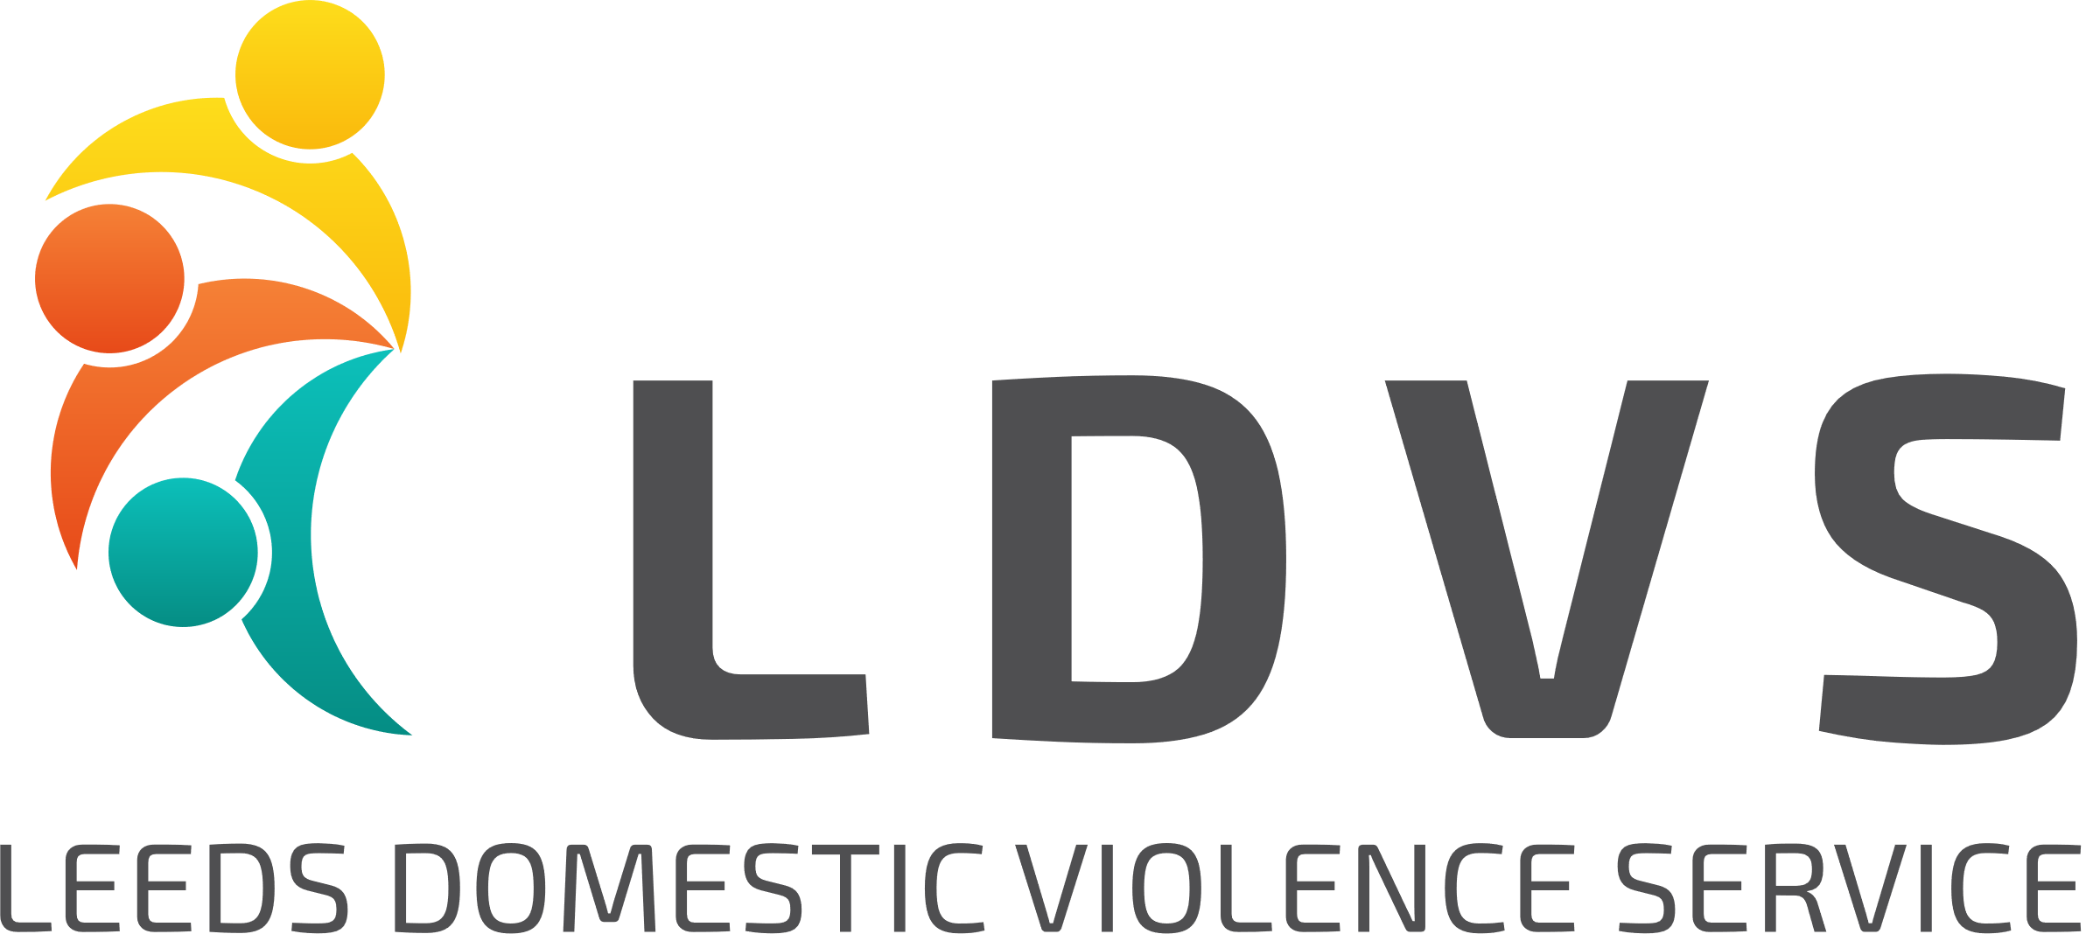

How to complete this referral:
By completing this referral form, you’re helping us to make contact with the client as safely and quickly as possible. We’d appreciate it if you could include as much information as possible - this saves the client from being asked the same questions twice and helps us to understand more about their particular needs and circumstances.
How to submit this referral:
Please email this form to: ldvs.referrals@lwa.cjsm.net via secure email.
If you do not have a secure email account, please contact our Helpline to discuss alternative secure referral methods: 0113 246 0401

Eligibility criteria for this service:
Please be sure to check that the client meets the following criteria before making the referral:
Client is affected/fleeing domestic violence or abuse including Stalking/HBV/Forced Marriage/FGM
The IDVA Service can support clients living outside of Leeds if the incident took place in Leeds. Refuge will accept referrals from outside of Leeds. For all other services clients must reside in Leeds to be eligible for support
Accompanying documents:
Please attach the following documents to this referral, if completed:
Safe Lives DASH/MARAC Paperwork

*Please complete all sections of this form to enable the referral to be processed as quickly as possible

How to get in touch:
If you have any questions about our service, eligibility criteria, or how to make a referral, please contact the Access & Assessment Team on 0113 246 0401

- Information about the person making the referral
Date of referral:
Please indicate which service you’d like to refer to: | Refuge  Community based support  (e.g. IDVA, Community DV Team, Support Group)
Please enter your name and contact details:
Referrer’s name
Organisation name/address
Role/ job title
Contact number
Contact email

Information about the person you are referring:
Contact information
First name |  |  |  |  | Date of Birth
Surname/last name
Has the client given their consent for this referral to be made?
*We are unable to accept the referral if the person has not given their consent.
Other names/alias’s
What do they prefer to be called?
Has the client been referred to MARAC? | Yes/No | If yes, who referred & when
Current address

Does the alleged perpetrator live at this address?
Type of property | Local Authority |  | Housing Assn |  |  | Owner/occupier
 | Temp. Accom |  | Family/friends |  |  | Refuge/Hostel
 | Other – please specify:

Telephone/email information
Contact telephone number
Is it safe to call them? | Yes No Don’t Know
Will they answer a withheld number? | Yes No Don’t Know
Is it safe to leave a message? | Yes No Don’t Know
Is it safe to write to the client? | Yes No Don’t Know
Email address:
Is it safe to send an email?
Any other information we should be aware of relating to their address or contacting them safely?

Next of kin – who can we contact in an emergency?
Name
Relationship
Contact information
Referrals to refuge only:
Has the client stayed in refuge before | Yes/No | If so, which refuge?
Reason for leaving that refuge

- Children
If the person being referred has children, please provide their names and DOBs below:
Name |  | DOB | Relationship to perpetrator
Are Social Care involved in this case?
(Please give details)

Name & contact details of social worker (if relevant)

- Reason for Referral
Why are you making this referral – how could this client benefit from our support?
Are there any known risks to working with this client?

- Alleged perpetrator/s
Information about the alleged perpetrator, if known:
Name
Gender | Female ☐ Male ☐ Other (please describe):_________________
Relationship to survivor
Address
DOB
Ethnicity
Has the incident been reported to the police?
If so are you aware if the alleged perpetrator has been arrested, charged?
Include details of any bail conditions you are aware of.
If there is more than one alleged perpetrator, please provide additional details in the box below:

- Accessibility requirements
Does this client require an interpreter? | Yes ☐ No☐  If yes, pleas state which language:
Does this client have any accessibility requirements | Yes ☐ No☐ Don’t Know ☐  If yes, please provide details:
What is this client’s nationality?
(If not British National) What is their immigration status?
(If not a British National) Do they have access to Public Funds? | Yes ☐ No ☐ Don’t know ☐

- Equalities monitoring
How would this client describe their gender? | Female ☐ Male ☐ Other (please describe):
Is their current gender different to the sex they were assigned at birth? | Yes ☐ No ☐  Don’t know ☐
Do they consider themselves to have any kind of disability?  (please tick any that apply) | Physical ☐ Learning ☐ Mental Health ☐  Deaf/ hearing impaired ☐ Blind/ visually impaired ☐  Long term health condition – give details  Something else – give details  Don’t Know ☐
How would they describe their ethnicity? | White British ☐ White Irish ☐ White Gypsy or Irish Traveller ☐  Any other White background (specify)  Asian Indian ☐ Asian Pakistani ☐ Asian Bangladeshi ☐  Any other Asian background (specify)  Chinese ☐ Arab ☐  White and Black Caribbean ☐ White and Black African ☐  White and Asian ☐  Any other mixed/ multiple background ☐  Black African ☐ Black Caribbean ☐  Any other Black background ☐  Other (please specify):
Do they have a faith/ religion? | No religion ☐ Buddhist ☐ Christian ☐ Hindu ☐ Jewish ☐  Muslim ☐ Sikh ☐ Don’t Know ☐  Other (specify):
What is their relationship status?  (tick one option) | Single ☐ Married ☐ Cohabiting but not married/ CP ☐  Civil partnership ☐ Divorced ☐  Separated ☐ In a relationship (not cohabiting) ☐  Widowed ☐
What is their sexual orientation?  (tick one option) | Heterosexual/ straight ☐ Gay woman/ Lesbian ☐  Gay man ☐ Bisexual ☐ Don’t Know ☐  Something else:_________________
Are they pregnant? | Yes ☐ When is EDD?  No ☐ Don’t know ☐
Economic Status

- Client support needs/ vulnerabilities
Please tell us more about any support needs the client may have: | Mental Health ☐  Physical Health ☐  Substance misuse ☐  Offending ☐
Additional details:

- Additional Risk information
 | Referred client | Alleged Perpetrator
Has there been any violent or aggressive behaviour to anyone else? | YES/NO | YES/NO
Are there any criminal convictions/offending history? | YES/NO | YES/NO
Are there any warning markers | YES/NO | YES/NO
Are there any other risks? | YES/NO | YES/NO
Give details

Thanks for taking the time to complete this referral.

To submit your completed document, please email to ldvs.referrals@lwa.cjsm.net

Before you send the referral, please check that your referral meets the criteria set out on the first page of this document, and that any relevant additional materials ie: Safe Lives Dash/MARAC Paperwork are attached.

If you have any queries, please contact the Access & Assessment Team on 0113 246 0401.

