Role Profile – People Team Administrator

Job Description

Job Title | People Administrator – female*
Salary | £15,124.20
Responsible To | People Advisor
Hours | 21 hours per week over 3 days
Contract | Permanent – hybrid working available

*This post will be subject to a basic DBS check and there is an Occupational Requirement under the Equality Act 2010 Schedule 9 (Part 1) for the post holder to be a woman.

Leeds Women’s Aid (LWA) is the largest women’s charity in Leeds, and has been providing support to women and children affected by Domestic Violence and Abuse (DV & A) for over 50 years. We are committed to our values and strive to embody them in everything we do. We provide a range of the very best services for vulnerable women and families who are victims and survivors of domestic, sexual & honour-based violence and abuse, forced marriage, trafficking, stalking and harassment.

LWA is the lead agency for Leeds Domestic Violence Service (LDVS), a consortium of 3 agencies offering support to women, men and transgender/non-binary people. This service works within a multi-agency framework and provides high quality, pro-active service to victims of domestic, sexual and honour-based violence and abuse, stalking and forced marriage, often those at the highest risk.

LWA is also the lead agency in the innovative and unique National Lottery Community Fund Funded Women’s and Girls Alliance (W&GAL), consisting of 12 women’s and girls’ organisations. Working with vulnerable women and girls, our vision is that many more women and girls in Leeds will have their needs met and be empowered to lead safer and healthier lives.

Purpose of Job
Reporting to the People Advisor, the People Administrator is responsible for the administration of people activities through the entire employee lifecycle, ensuring work is completed accurately, efficiently and in line with policies and procedures.

The role has ownership of recruitment administration, including advertising vacancies, responding to applicants, coordinating recruitment processes, and providing ongoing support to recruiting managers.

The People Administrator is also responsible for monitoring and managing the People Team inbox and acts as the first point of contact for people‑related queries, demonstrating a high standard of professionalism and communication in all interactions.

Physical Conditions
This post requires cover over 3 days a week, between Monday to Friday, which can either be completed fully in the LWA offices in Killingbeck or on a 1 day hybrid arrangement.

Responsible to:
This role is line managed by, and responsible to, the People Advisor, and ultimately the Chief Executive and Trustees of LWA, and will work according to policies and procedures agreed by them.

There are no line management responsibilities.

Main Duties

Administration Duties
- Undertake administrative duties including drafting letters and documentation, which support various People Team processes. For example, documents relating to new starters, leavers, contract changes, flexible working, compassionate leave etc.
- Act as the first point of contact for the People Team, managing and responding to queries via the People Team inbox and escalating appropriately where required.
- Maintain and update standard People Team templates, forms, and documentation in line with current policies and legislation.
- Maintain and update BreatheHR, LWA’s HR/People database. This includes setting up new employees, updating annual leave and changes, processing leavers, running reports, undertaking data checks and audits and any other reasonable duties.
- Maintain accurate records of all contract changes which impact on payroll, and ensure Payroll is informed of these changes on a monthly basis.
- Track contract expiration dates on BreatheHR, liaising with relevant manager to confirm action to be taken.
- Monitor DBS expiry dates on BreatheHR and liaise directly with individuals to confirm required actions and ensure DBS renewals are completed in order to maintain compliance.
- Maintain hard copy and electronic employee personal records, including delivering, receiving, filing and tracking employment documents such as references and signed People Team paperwork in an efficient manner.
- Track and report on Equality & Diversity Monitoring information for all recruitments, and the workforce in general
- Provide general administrative support to the People Advisor, Head of People and Culture, and across the wider organisation, supporting effective communication and information sharing as required.

Recruitment
- Support all recruiting managers with recruitment including advertising vacancies on our website, and any relevant jobs board, reviewing the market to ensure full visibility of the roles.
- Act as the main point of contact for recruitment activity, responding to all applicants, acknowledging applications, chasing missing information, and keeping applicants informed throughout the process.
- Provide first line advice to recruiting managers around the recruitment and onboarding process.
- Store, acknowledge and organise job applications, ensuring all applications are forwarded in a timely manner after the closing date.
- Create shortlisting matrices for any job vacancy to support the shortlisting panel in making informed decisions, and gather completed shortlisting documentation from managers.
- Coordinate interviews and assessments, including liaising with candidates and recruiting managers, and collate interview notes and outcomes.
- Inform unsuccessful candidates following interview in a timely and professional manner.
- Provide any other general administration support the People Advisor, Head of People and Culture, and across the wider organisation as may be required from time to time.

Safeguarding
- Administering pre-employment checks including DBS, right to work in the UK and reference checks.
- Maintain strict confidentiality in all aspects of work as required and work in line with GDPR, at all times.

Learning & Development
- Undertake administration in relation to employee training initiatives
- Maintain records of compulsory training attendance in BreatheHR and set up IHasco training for new starters for example GDPR, safer recruitment, first aid, health and safety training undertaken and report on this when required.

General
- Provide excellent customer service to all internal and external stakeholders.
- Work with the People Advisor and Head of People and Culture to promote employee wellbeing, providing useful resources and information to employees as required.
- Support the People Team to implement any new systems together with external providers including undertaking data entry and data checks, communicating updates and supporting with the administration of any materials.
- Undertake any other responsibilities or tasks that are within the employee’s skills and abilities whenever reasonably instructed and commensurate to this role.
- Maintain high levels of confidentiality and uphold GDPR principles
- Actively promote diversity in the organisation
- Embody LWA’s values, acting as a role model
- Attend full team and team meetings when required

Person Specification
Our ideal candidate will be able to demonstrate
Knowledge & Experience | How Assessed:  A = Application  I = Interview
Working with a multi-faceted workload where good organisational and prioritisation skills were pivotal to ensuring accurate and timely delivery of tasks. | A / I
Commitment to a high standard of customer service | A / I
Experienced and confident user of Microsoft Word, Microsoft Excel, Microsoft Outlook and Microsoft PowerPoint as well as video conferencing platforms i.e., Teams, Zoom | A
Understanding of recruitment lifecycle administration procedures | A / I
Previous experience in a HR/People Team or recruitment role | A
Experience of working with HR/People systems | A
Basic understanding of safeguarding | A / I

Skills & Abilities
Good communication skills, both written and verbal. | A / I
Able to establish and maintain professional interpersonal relationships | I
Able to accurately document, record and maintain information and data | A / I
Able to work with self-direction and flexibility, especially with respect to taking initiative, prioritising multiple tasks, and using good judgement to resolve problems | I
'Can do' attitude, with a methodical approach to work and strong prioritisation skills | I
Team player | I
Integrity - the role requires appropriate handling of confidential and sensitive information | A / I
IT literate and proficient in the use of Microsoft Word, Excel and PowerPoint | A
Flexible and resilient, in order to adapt to changing situations. | I
Actively participates in continued professional development. | A / I

Qualifications/ Professional Membership
GCSE Maths and English (or equivalent) at grade C/4 or above, plus A Level, NVQ Level 3, BTEC in Office/Business Administration, CIPD level 3 or equivalent practical experience | A

Personal Qualities & Competencies
The People Team Administrator must share and promote LWA’s values (see below) | I
Willing to undertake additional responsibilities or provide support to colleagues to ensure organisational aims are met | I
Supportive of diversity and inclusion | A / I
Sympathetic to the aims of the organisation in supporting and championing women’s rights | I

LWA’s Values

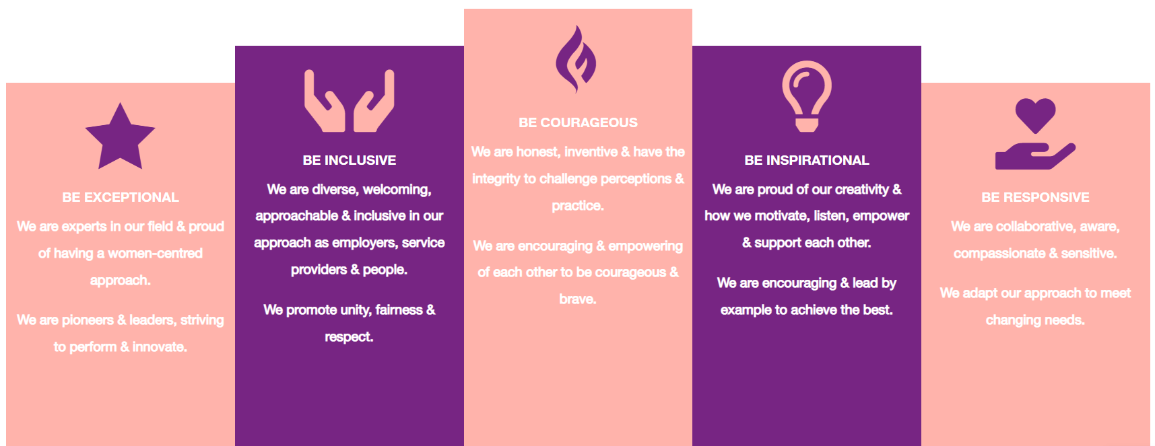

1. Be Exceptional
- We are experts in our field & proud of having a women-centred approach
- We are pioneers & leaders, striving to perform & innovate

2. Be Courageous
- We are honest, inventive & have the integrity to challenge perceptions & practice
- We are encouraging & empowering of each other to be courageous & brave

3. Be Inclusive
- We are diverse, welcoming, approachable & inclusive in as employers, service providers & people
- We promote unity, fairness & respect

4. Be Inspirational
- We are proud of our creativity & how we motivate, listen, empower & support each other
- We are encouraging & lead by example to achieve the best

5. Be Responsive
- We are collaborative, aware, compassionate & sensitive
- We adapt our approach to meet changing needs

