Role Profile

Job Description

Job Title | Refuge Night Worker, Female*, Leeds
Salary | £25,480.00 (FTE 35 hours per week)
Responsible to | Out-of-Hours Team Leader
Hours | Monday, Tuesday and Wednesday  10 pm to 8:30 am
Contract | FTC – Maternity Cover, 12 months

This post will be subject to an enhanced DBS check and there is an Occupational Requirement under the Equality Act 2010 Schedule 9 (Part 1) for the post holder to be a woman.

Leeds Women’s Aid (LWA) is the largest women’s charity in Leeds, and has been providing support to women and children affected by Domestic Violence and Abuse (DV & A) for over 50 years. We are committed to our values and strive to embody them in everything we do. We provide a range of the very best services for vulnerable women and families who are victims and survivors of domestic, sexual & honour-based violence and abuse, forced marriage, trafficking, stalking and harassment.

LWA is the lead agency for Leeds Domestic Violence Service (LDVS), a consortium of 3 agencies offering support to women, men and transgender/non-binary people. This service works within a multi-agency framework and provides high quality, pro-active service to victims of domestic, sexual and honour-based violence and abuse, stalking and forced marriage, often those at the highest risk.

LWA is a member of the unique Women & Girls Alliance – Leeds, consisting of 12 women’s and girls’ organisations. Working with vulnerable women and girls, our vision is that many more women and girls in Leeds will have their needs met and be empowered to lead safer and healthier lives.

Purpose of Job

The Refuge Night Worker provides specialist guidance and support to our residents living in our refuge accommodation and offers a 24-hour helpline service to victim-survivors. The helpline is the first point of contact for, and access to LDVS services for any person experiencing domestic violence and abuse. The role also contributes to the delivery of high-quality, trauma-informed and person-centred administrative and support services within our main LDVS refuge accommodation.

The successful candidate will be a vital role within our dedicated team, ensuring the effective operation of our refuge and helpline services. They will demonstrate a strong commitment to supporting victim-survivors of domestic violence and abuse, prioritising their safety, wellbeing and recovery.

This role will involve cleaning duties, including offices, the staff kitchen and some communal areas, as required.

This role involves lone working as a member of LWA; however, a subcontract arrangement is in place, ensuring you are accompanied by a security officer. An on-call management process is also in place to provide additional support as needed throughout the night.

Physical Conditions

The post will be based in our main LDVS refuge accommodation.

Due to the role involving lone working at night, you will not be expected to leave site. In the event of an emergency, on-call management may occasionally visit dispersed properties or other LWA refuge sites within Leeds. Where possible, concerns will initially be addressed via telephone with yourself, however, if it becomes necessary for someone to attend another site, the designated on-call colleague will coordinate with the security officer to implement the most appropriate response.

Economic Conditions

This is a part-time post, with a salary of £25,480.00 FTE

Responsibilities

Responsible to:

OOH Team Leader who reports to the Operations Manager (Refuge).
All paid members of staff are accountable to the Chief Executive, and ultimately the Trustees of Leeds Women’s Aid, and will work according to policies and procedures agreed by them.

And close liaison with:

Refuge Team, Access & Assessment Team, LWA and LDVS services

Main Duties

- Deliver the helpline and refuge accommodation service, ensuring these are accessible, responsive and inclusive to meet the diverse needs of victim-survivors.
- Provide high-quality, trauma-informed support to victim-survivors of domestic violence and abuse; including emotional support, risk assessment, safety planning and appropriate signposting to relevant services.
- Provide support to residents living within refuge accommodation during out-of-hour periods. Support to other sites is primarily delivered via telephone; however, on occasion, you may liaise with our on-call colleague; who will attend the external site or provide further guidance.
- Maintain accurate and comprehensive case files and records, ensuring compliance with data protection and organisational policies.
- Provide front-of-house and operational support at the main LDVS refuge.
- Provide a clear handover to Domestic Violence Support workers in the morning, ensuring continuity of care and guidance for ongoing support.
- Night shifts generally experience a lower volume of helpline calls compared with evening or weekend shifts. The helpline primarily provides support to victim-survivors of domestic violence and abuse; however, service users may seek assistance with mental health concerns. In such instances, calls are appropriately signposted to relevant services. A strong understanding of trauma informed practices and/or mental health support will be advantageous in this role.
- Respond promptly to emergencies and safeguarding concerns involving adults or children, seeking guidance and support from on-call management, where necessary, in accordance with safeguarding legislation and organisational policies.
- Ensure the safety and security of refuge residents and buildings by monitoring CCTV, conducting regular welfare and security checks and responding to identified risks.
- Ensure compliance with health and safety standards with the main LDVS refuge building, promptly reporting any repairs, defects or maintenance issues.
- This role will involve cleaning duties, including offices, the staff kitchen and some communal areas, as required.
- On rare occasions, typically in emergency situations, assist with preparing refuge units for new admissions, ensuring that all safety measures and standards are upheld.

General

- Attend staff meetings and other training events as required.
- To uphold LWA's policies, with particular reference to confidentiality, health and safety and equity, diversity and inclusion.
- To carry out any other duties or training commensurate with the post.
- To carry out any other duties that are reasonably required by LWA.

Person Specification

Our ideal candidate will be able to demonstrate

Experience | How Assessed:  A = Application Letter  I = Interview
- Work with victim-survivors of domestic violence and abuse OR supporting vulnerable adults, children and young people. | A I
- Provide customer service advice or support, delivered via telephone and/or face-to-face interactions. | A I
- Work within an operational multi-agency environment. | A I
- Maintain accurate and clear case files and records, ensuring information is easy to understand and free from jargon. | I
- Demonstrate effective communication skills, including the ability to listen to sensitive disclosures, negotiate where appropriate and build positive working relationships. | I
- Lone Working | A I

Understanding
- Trauma informed practice | A I
- Violence against women and children. Domestic, sexual and honour-based violence and abuse, stalking, forced marriage, modern slavery (to name a few). | A I
- Adult and Children & Young People Safeguarding. | A
- Practical and legal remedies available to victim-survivors. | A I
- Voluntary and statutory organisations involved in the response to domestic violence and abuse. | I
- Work with vulnerable adults experiencing mental health and/or dependency on alcohol or substances. | A I
- Health and Safety and/or security of supported accommodation. | A

Skills
- Crisis Management or the ability to respond to emergencies under-pressure. | A I
- Work on own initiative. | I
- Listen with empathy and deliver compassionate approaches. | I
- Excellent IT skills i.e. to be able to present complex information accurately and clearly. | A
- Build positive and supportive relationships with service users while maintaining professional boundaries. | A I

Professional Qualification
- Domestic Violence and Abuse (desirable) | A
- Trauma and/or Mental Health (desirable) | A
- Health and Social Care (desirable) | A
Personal Qualities & Competencies
- Empathetic and compassionate approach. | I
- Act with integrity and respect. | I
- Teamwork and collaboration. | A I
- Critical thinking and decision-making. | A I
- Commitment to equity, diversity, and inclusion; and work in a manner that is an anti-discriminatory and actively challenges racism. | I
- Your personal values align with the values of Leeds Women’s Aid. | I

LWA’s Values

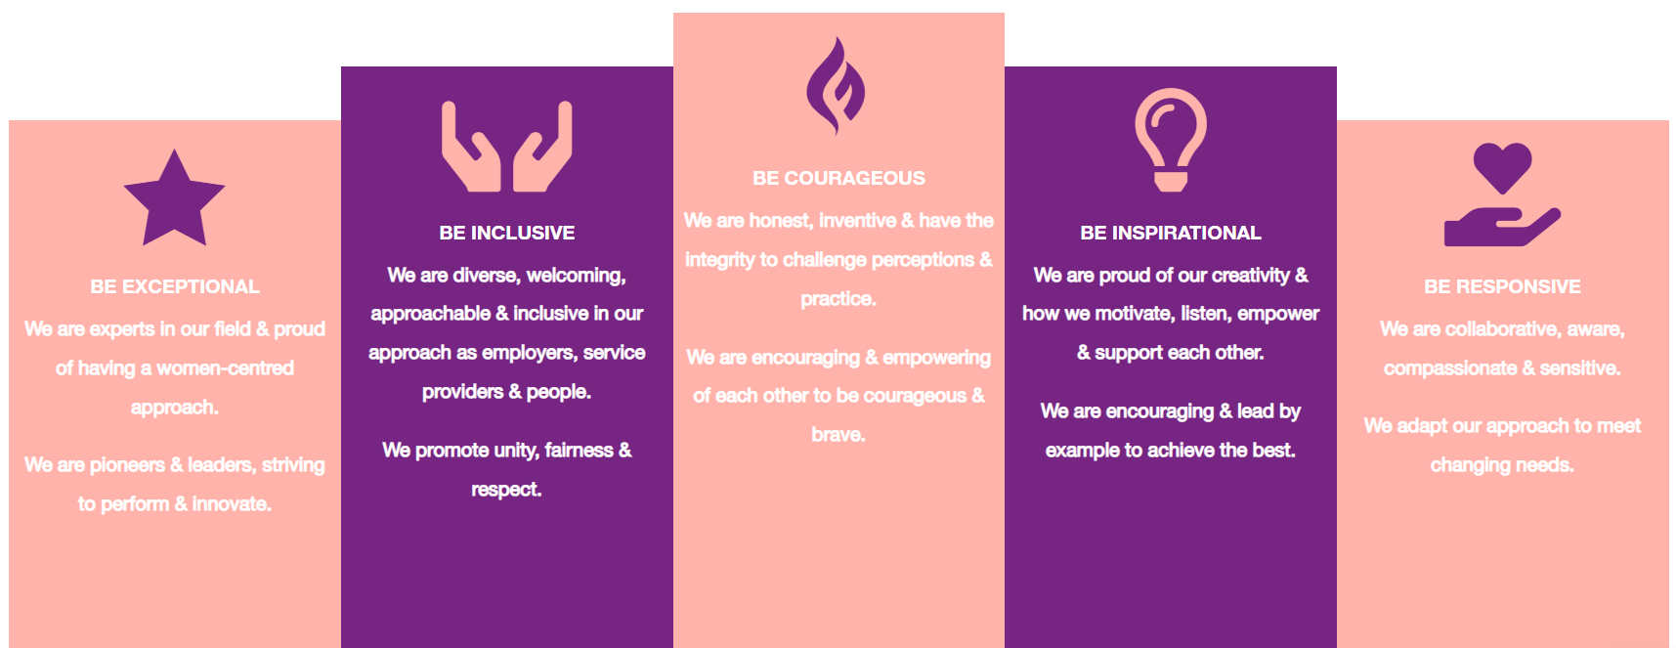

1. Be Exceptional
• We are experts in our field & proud of having a women-centred approach
• We are pioneers & leaders, striving to perform & innovate

2. Be Courageous
• We are honest, inventive & have the integrity to challenge perceptions & practice
• We are encouraging & empowering of each other to be courageous & brave

3. Be Inclusive
• We are diverse, welcoming, approachable & inclusive in as employers, service providers & people
• We promote unity, fairness & respect

4. Be Inspirational
• We are proud of our creativity & how we motivate, listen, empower & support each other
• We are encouraging & lead by example to achieve the best

5. Be Responsive
• We are collaborative, aware, compassionate & sensitive
• We adapt our approach to meet changing needs

