Role Profile

Job Description

Job Title | Independent Domestic Violence Advocate (IDVA)
Salary | £29,860 per annum
Responsible to | Lead IDVA (Casework Team)
Hours | Full time (35 hours)
Contract | Permanent

This post will be subject to an enhanced DBS check and there is an Occupational Requirement under the Equality Act 2010 Schedule 9 (Part 1) for the post holder to be a woman.

Leeds Women’s Aid (LWA) is the largest women’s charity in Leeds, and has been providing support to women and children affected by Domestic Violence and Abuse (DV & A) for over 50 years. We are committed to our values and strive to embody them in everything we do. We provide a range of the very best services for vulnerable women and families who are victims and survivors of domestic, sexual & honour-based violence and abuse, forced marriage, trafficking, stalking and harassment.

LWA is the lead agency for Leeds Domestic Violence Service (LDVS), a consortium of 3 agencies offering support to women, men and transgender/non-binary people. This service works within a multi-agency framework and provides high quality, pro-active service to victims of domestic, sexual and honour-based violence and abuse, stalking and forced marriage, often those at the highest risk.

LWA is a member of the unique Women & Girls Alliance – Leeds, consisting of 12 women’s and girls’ organisations. Working with vulnerable women and girls, our vision is that many more women and girls in Leeds will have their needs met and be empowered to lead safer and healthier lives.

Purpose of Job
To work within a team of IDVAs within a multi-agency framework providing a high quality, proactive service to victims of domestic, sexual and honour-based violence and abuse, stalking and forced marriage - often those at the highest risk.

Physical Conditions
The post will be based in Leeds Women’s Aid Head office (with some home-working possible after full training). You will be required to work at other locations as part of this role, for example, at the Leeds Courts and Front Door Safeguarding Hub.

Economic Conditions
This is a full-time post (35 hours per week) with a salary of £29,860 per annum

Responsibilities

Responsible to:
The IDVA will be line managed by, and be responsible to the Lead Worker.
All paid members of staff are accountable to the Chief Executive, and ultimately the Trustees of Leeds Women’s Aid, and will work according to policies and procedures agreed by them.
*Occupational Requirement – female
This post is restricted to female applicants under Schedule 9, Part 1 of the Equality Act 2010.
This requirement is applied lawfully and proportionately, reflecting the organisation’s provision of specialist women-led and women-centred services and the need to maintain safety, trust and authenticity in leadership and external representation.
In addition, the role involves direct professional involvement in safeguarding, domestic abuse practice oversight and regular engagement with women affected by male violence and abuse, for whom access to a female professional is necessary to ensure safety, dignity and effective engagement.

Main Duties

- The IDVA will predominantly work with women experiencing domestic, sexual and honour-based violence and abuse, stalking, coercive & controlling behaviour and forced marriage.
- To offer support, advice, information and advocacy to victim-survivors on a one-off or on-going basis.
- To liaise with the police, courts, health professionals and other agencies to ensure appropriate and timely responses to domestic violence incidents.
- To undertake risk assessments and safety planning with victim-survivors.
- Perform in-depth casework within the legal process.
- Support clients before, during and after court proceedings, including attending trials and other court hearings.
- To maintain accurate records of all work undertaken
- Participate in multi-agency meetings and joint working arrangements (when required) at the 'Daily Risk Assessment Meeting’ (DRAM) and Multi Agency Risk Assessment Conferences (MARACs).
- Support clients on the phone and face-to-face, and perform visits in line with Leeds Women’s Aid Lone Working and Personal Safety Policy.
- Represent at weekly DVDS (also knowns as Clare’s Law) meetings.
- To participate in regular supervision and team meetings.
- To act as an Institutional Advocate on behalf of victims of abuse.
- Work with, and assess where appropriate victims of domestic abuse of any gender.
- To assist the IDVA Team Leader in the monitoring and evaluation of the organisation’s work, where relevant.
- To assist the IDVA Team Leader to investigate ways to develop the IDVA service offered to clients.
- To contribute to the preparation of reports and the development of publicity material, as necessary.
- To attend external and internal meetings as agreed with the Lead IDVA and IDVA Team Leader.
- Work with clients in line with Leeds Women’s Aid & LDVS’s policies and procedures.
- To attend relevant training and development opportunities to enhance skills and knowledge.
- To undertake any other duties as may be deemed consistent with the requirements of the post.

General

- Attend staff meetings and other training events as required.
- To uphold LWA's policies, with particular reference to confidentiality, health and safety and equity, diversity and inclusion.
- To carry out any other duties or training commensurate with the post.
- To carry out any other duties that are reasonably required by LWA

Person Specification

We welcome applications from people who bring most of the following and who can demonstrate alignment with our values and commitment to women-centred practice. We do not expect you to meet every element of this profile.

Experience | How Assessed:  A = Application Letter  I = Interview
- Experience of either working as an IDVA, or directly with IDVA’s, and has a comprehensive understanding of the dynamics of domestic abuse. | C/I
- In-depth telephone and face to face advice work | C
- Recording, tasking and reviewing detailed information | I
- Manage a caseload, including support planning, risk assessing and multi-agency working. | C/I
- Advocating on behalf of clients | C
- Working with other voluntary and statutory services involved in the response to domestic violence and abuse. | C/I
- A sound understanding of the civil and criminal justice system and procedures relating to domestic violence. | I
- Good organisational skills and the ability to manage a high-volume workload. | I
- A commitment to equal opportunities and diversity | I
- Knowledge and experience of Safeguarding Practices and Procedures | I

Understanding
- Violence against women (and their children); and domestic, sexual and honour-based violence and abuse, stalking and forced marriage. | C/I
- The impact of trauma on vulnerable adults | I
- The legal and practical remedies available to victim-survivors | I
- IDVA work including risk assessments, safety planning, care pathway and best practice when working with high risk victim-survivors | C/I
- Advocate clients’ views at the Multi Agency Risk Assessment Conference (MARAC) and Daily Risk Assessment Meeting (DRAM) | C/I
- Safeguarding issues in relation to children, young people and vulnerable adults and the legal responsibilities surrounding these issues | I
- Clear understanding of equality issues and marginalisation of various groups and communities | I
- Multi-agency partnerships and information sharing in domestic violence and abuse cases | I

Skills
- Experience of crisis management, risk minimisation and of making decisions in difficult situations | C/I
- Excellent interpersonal and communication skills (written and verbal) | C/I
- Good technological skills, including the ability to use electronic databases and software, and being able to present information clearly | C/I

Professional Qualification
- Hold a Safe Lives (CAADA) IDVA training qualification or equivalent, a relevant degree, a vocational qualification, or have substantial equivalent experience of DV&A support work. | C
Personal Qualities & Competencies
- Have values consistent with those of LWA | C/I
- Act with integrity and respect when interacting with service users, employees, agencies and individuals | I
- Are committed to upholding LWA’s policies and procedures | I
- Are committed to diversity and working in an anti-discriminatory way | C/I

LWA’s Values
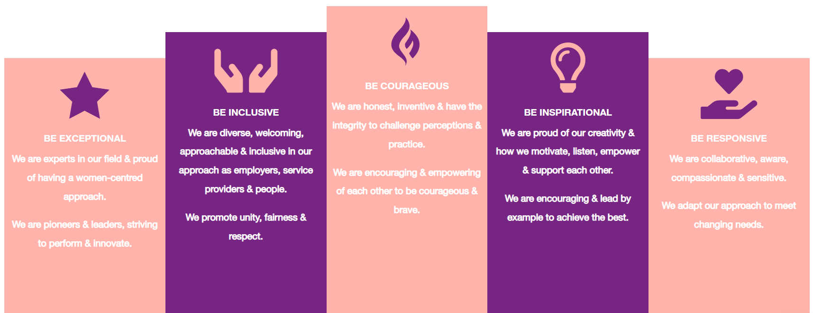

1. Be Exceptional
• We are experts in our field & proud of having a women-centred approach
• We are pioneers & leaders, striving to perform & innovate

2. Be Courageous
• We are honest, inventive & have the integrity to challenge perceptions & practice
• We are encouraging & empowering of each other to be courageous & brave

3. Be Inclusive
• We are diverse, welcoming, approachable & inclusive in as employers, service providers & people
• We promote unity, fairness & respect

4. Be Inspirational
• We are proud of our creativity & how we motivate, listen, empower & support each other
• We are encouraging & lead by example to achieve the best

5. Be Responsive
• We are collaborative, aware, compassionate & sensitive
• We adapt our approach to meet changing needs

