Role Profile

Job Description

Job Title | Multi-Agency Meeting Advocate – female*
Salary | £27,700
Responsible to | IDVA Team Leader
Hours | 35 hours per week
Contract | Fixed Term until March 2026 (subject to extension)

This post will be subject to an enhanced DBS check and there is an Occupational Requirement under the Equality Act 2010 Schedule 9 (Part 1) for the post holder to be a woman.

Leeds Women’s Aid (LWA) is the largest women’s charity in Leeds, and has been providing support to women and children affected by domestic abuse for over 45 years. We are committed to our values and strive to embody them in everything we do. We provide a range of the very best services for vulnerable women and families who are victims and survivors of domestic, sexual & honour-based violence and abuse, forced marriage, trafficking, stalking and harassment.

LWA is the lead agency for Leeds Domestic Violence Service (LDVS), a consortium of three agencies offering support to women, men and transgender/non-binary people. This service works within a multi-agency framework and provides high quality, pro-active service to victims of domestic, sexual and honour-based violence and abuse, stalking and forced marriage, often those at the highest risk.

LWA is a member of the unique Women & Girls Alliance – Leeds, consisting of 11 women’s and girls’ organisations. Working with vulnerable women and girls, our vision is that many more women and girls in Leeds will have their needs met and be empowered to lead safer and healthier lives.

Purpose of Job

This is a new team which will be part of an established IDVA Team and linked to our Access and Assessment Team. The team will be focusing on immediate support and advocacy for high risk victim-survivors through the multi-agency processes in place in Leeds. The team will work closely with, and support, the Front Door Safeguarding Hub, attending the Daily Risk Assessment Meeting (DRAM) and the Multi-Agency Risk Assessment Conference (MARAC) and leading on actions.

The current IDVA Team has a focus on criminal law and IDVA’s directly support high risk victim survivors through the complex criminal justice system. The team also has two senior IDVA roles focusing on young victim-survivors and victim-survivors with complex needs.

As a Multi-Agency Meeting Advocate, you will be responsible for researching, preparing for and attending the Daily Risk Assessment Meeting (DRAM) and the Multi-Agency Risk Assessment Conference (MARAC) and leading on actions.

Physical Conditions

The Multi-Agency Meeting Advocate will be based within the main LWA office with optional hybrid working arrangements.

You may be required to work at other locations as part of this role, for example, Front Door Safeguarding Hub.

Economic Conditions

This is a full-time post with a salary of ££27,700.

Responsibilities

Responsible to:

The Multi-Agency Meeting Advocate will be line managed by, and be responsible to, the Lead IDVA.
All paid members of staff are accountable to the Chief Executive, and ultimately the Trustees of Leeds Women’s Aid, and will work according to policies and procedures agreed by them.

Main Duties

- To support victim-survivors of domestic, sexual and honour-based violence and abuse, stalking, coercive & controlling behaviour and forced marriage.

- To review and analyse the list of cases for DRAM and MARAC, gathering and compiling relevant information and documentation on each case and identifying key risk factors and support needs for individuals involved.

- To contact high risk victim-survivors prior to DRAM and MARAC to assess their level of risk, to discuss their support needs, safety plan and to obtain their views for the meeting.

- To attend DRAM and MARAC to represent the views of and to advocate for victims of domestic violence and abuse.

- To work within a multi-agency framework in order to offer effective services to victims and reduce risk.

- Based on the victim-survivors support needs, with consent, to refer to internal LDVS teams, external organisations and signpost where appropriate.

- Carry out any actions from DRAM/MARAC as required.

- Working alongside referrers from external agencies around safe contact with victim/survivors.

- To contribute to the development of protocols and procedures to enhance the effectiveness of DRAM and MARAC processes.

- To ensure case files and records are accurate and complete and that they are kept in compliance with data protection legislation and internal case recording guidance

- To provide a service which recognises the diverse needs to victim-survivors ensuring the service is accessible to all.

- To provide support and guidance to LWA and LDVS staff to develop their skills, understanding and awareness of supporting victim-survivors of domestic abuse.

- To proactively seek victim feedback and to ensure this is used effectively in the monitoring and evaluation of LDVS and the IDVA Team and is used to drive continuous service improvement.

- To attend any training relevant to the role, some of which may have assessment requirements such as the Independent Domestic Violence Advisor (IDVA) training.

General

- Attend staff meetings and other training events as required.

- To uphold LWA's policies, with particular reference to confidentiality, health and safety and equity, diversity and inclusion.

- To carry out any other duties or training commensurate with the post.

- To carry out any other duties that are reasonably required by LWA.

Person Specification

Our ideal candidate will be able to demonstrate;

Experience | How Assessed:  A = Application Letter  I = Interview
1. Telephone based and/or face to face advice and/or support work | A/I
2. Supporting vulnerable people | A
3. Working within an operational multi-agency environment | A/I
4. Advocating on behalf of service users | A/I
5. Safeguarding practices and procedures | I

Understanding
6. Violence against women and domestic, sexual and honour- based violence and abuse, stalking and forced marriage. | A
7. Child protection and adult safeguarding issues and procedures | I
8. DRAM, MARAC and Domestic Abuse Disclosure Scheme | A/I
9. Trauma-informed approaches and the impact of trauma on victim-survivors and their children | A
10. Risk assessments, safety planning, care pathways and best practice when working with high risk victim-survivors | A/I
11. Criminal justice system and legal processes including the legal and practical remedies available to victim-survivors | I
12. Multi-agency partnerships and other voluntary and statutory services involved in the response to domestic abuse | I
13. The ‘whole family approach’ and ‘asset-based’ ways of working | I

Skills
14. Excellent crisis management skills and the ability to deal with stressful and difficult situations under pressure | I
15. Good organisational skills and the ability to manage a high volume workload | A
16. Excellent interpersonal and communication skills (written and verbal) | A/I
17. Excellent IT skills and be able to present complex information clearly | A

Professional Qualification
18. SafeLives IDVA training qualification or equivalent (DESIRABLE) or willingness to undertake this if required | A
Personal Qualities & Competencies
19.To have values in line with those of LWA | I
20. To act with integrity and respect when interacting with service users, employees, agencies and individuals | A
21. To be committed to upholding LWA’s policies and procedures | A
22. To be committed to diversity and working in an anti- discriminatory way | A

LWA’s Values
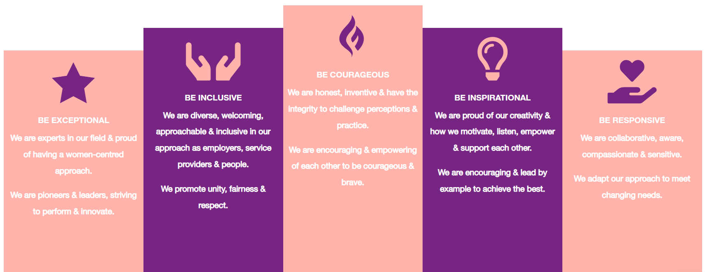

1. Be Exceptional
• We are experts in our field & proud of having a women-centred approach
• We are pioneers & leaders, striving to perform & innovate

2. Be Courageous
• We are honest, inventive & have the integrity to challenge perceptions & practice
• We are encouraging & empowering of each other to be courageous & brave

3. Be Inclusive
• We are diverse, welcoming, approachable & inclusive in as employers, service providers & people
• We promote unity, fairness & respect

4. Be Inspirational
• We are proud of our creativity & how we motivate, listen, empower & support each other
• We are encouraging & lead by example to achieve the best

5. Be Responsive
• We are collaborative, aware, compassionate & sensitive
• We adapt our approach to meet changing needs

