


Role Profile

Job Description

Job Title | Personal Assistant to Chief Executive and Board
Salary | £27,000 FTE per annum pro rata – depending on hours
Responsible to | Chief Executive
Hours | 21 – 28 hours (flexible)  Some evening meetings
Contract | 10-month fixed term (from start date)

This post will be subject to a basic DBS check and there is an Occupational
Requirement under the Equality Act 2010 Schedule 9 (Part 1) for the post holder to be a woman.

Leeds Women’s Aid (LWA) is the largest women’s charity in Leeds, and has been providing support to women and children affected by Domestic Violence and Abuse (DV & A) for over 50 years. We provide a range of the very best services for vulnerable women and families who are victims and survivors of domestic, sexual & honour-based violence and abuse, forced marriage, trafficking, stalking and harassment.

LWA is the lead agency for Leeds Domestic Violence Service (LDVS), a consortium of 3 agencies offering support to anyone over 16 in Leeds affected by domestic abuse. This service works within a multi-agency framework and provides high quality, pro-active service to victims of domestic, sexual and honour-based violence and abuse, stalking and forced marriage, often those at the highest risk.

LWA is also a member of the unique Women & Girls Alliance – Leeds, consisting of
12 women’s and girls’ organisations working to support and empower women and girls. Women Friendly Leeds (WFL) is a social movement born of the Women & Girls Alliance, working towards a city that is better for women, better for everyone, WFL delivers three key projects.

Purpose of Job

The Personal Assistant is responsible for providing professional, proactive and confidential administrative support to the Chief Executive, Senior Leadership Team and Board. The successful candidate will provide accurate, efficient and proactive diary and email management, arrange in-house and external meetings, minute meetings, prepare presentations and make travel arrangements as well as other ad hoc duties.

This is a maternity cover post that focuses on LWA’s core governance and leadership functions, ensuring continuity whilst the substantive Executive Assistant is on leave. This role does not include wider Executive Assistant responsibilities, making it ideal for someone with strong admin and governance coordination experience.

The successful candidate will have excellent organisational skills, demonstrate close attention to detail and be able to work in a focused way in a busy environment.

Physical Conditions

The post will be a hybrid role, based in LWA’s Head Office.

Economic Conditions

This is a part-time post with a salary based on £27,000 FTE per annum (FTE is 35 hours per week). 21 hours is £16,200 pa and 28 hours is £21,600.

Responsibilities

Responsible to:

The Personal Assistant will be line managed by, and responsible to, the Chief Executive.

Responsible for:

There are no line management responsibilities.

Main Duties

SLT and Chief Executive Support

The Personal Assistant must be flexible, adaptable and able to prioritise a busy and varied role whilst maintaining strictest confidentiality. She will be expected to:

- Coordinate and schedule all Senior Leadership Team (SLT) meetings
- Liaising with the Chief Executive and SLT; support the servicing of Senior Leadership Team (SLT) and other relevant meetings including: supporting with the preparation and distribution of agendas; producing accurate and timely minutes; supporting with the creation and distributing documentation and action plans.
- Provide administrative support to the Chief Executive and SLT
- Undertake diary and email management of Chief Executive if required
- Ensure reports and relevant documents are fully accessible to all relevant people
- Develop and maintain relevant paper and electronic filing systems to provide ease of information access
- Undertake relevant operational and project work as required by the SLT.

Board and Governance Support

- Coordinate and schedule all Board of Trustees and Committee meetings. Committee meetings are 4.00 – 6.00 pm and Trustees meetings are 3.00 – 7.00 pm.
- Liaising with the Chief Executive and Chair; support the servicing of Board of Trustees, sub-committee meetings and other relevant meetings including: supporting with the preparation and distribution of agendas; producing accurate and timely minutes; supporting with the creation and distributing documentation and action plans.
- Support with administrative arrangements for Trustee meetings and site visits including arranging locations, travel and accommodation where required.
- Provide administrative support to the Chief Executive, Chair and trustees
- Ensure governance arrangements and reports are fully accessible to all relevant people
- Ensure governance database records are kept up to date - including Board and Committee membership, attendance, terms of office and contact details
- Develop and maintain relevant paper and electronic filing systems to provide ease of information access
- Undertake relevant operational and project work as required by the Board

General

- To work in line with, and follow, the policies and procedures of LWA.
- To attend staff meetings and other training events as required.
- To undertake any other duties as may be deemed consistent with the requirements of the post
- Maintain relationships with internal and external stakeholders
- To act at all times in line with LWA’s values.
- To uphold LWA's policies, with particular reference to confidentiality, health and safety and equity, diversity and inclusion.

Person Specification

Our ideal candidate will be able to demonstrate

Experience | How Assessed:  A = Application Letter  I = Interview
- Experience of working within a personal assistant function | A / I
- Experience of working independently and within a team | A / I
- Experience of exercising discretion and demonstrate political sensitivity | I
- Experience of producing accurate and timely minutes of meetings | A
- Experience of complying with GDPR | A / I
- Experience of interacting with internal and external stakeholders | A / I
- Experience of using Microsoft office packages including Teams | A
- Experience of working in a governance function including arranging, servicing and minuting high level and confidential meetings | A / I

Skills | How Assessed:  A = Application Letter  I = Interview
- A high standard of English and maths | A
- Strong interpersonal and communication skills, with the ability to build effective working relationships. | I
- Ability to organise own workload and manage multiple deadlines | A / I
- Excellent attention to detail | A / I

Personal Qualities & Competencies | How Assessed:  A = Application Letter  I = Interview
- Must share and promote LWA’s values (see over) | I
- Proactive and able to act on own initiative | I
- Flexible and adaptable | I
- Willing to undertake additional responsibilities or provide support to colleagues to ensure organisational aims are met | I
- Supportive of diversity and inclusion | I
- Supportive of the aims of the organisation in supporting and championing women’s rights | I
- Ability to know when to escalate issues and when to ask for help | I
- Wish for driving continuous improvement in terms of both personal development and functional elements of role | I
- Ability to provide excellent customer care to all stakeholders, and be confident in working with high level stakeholders | I

LWA’s Values

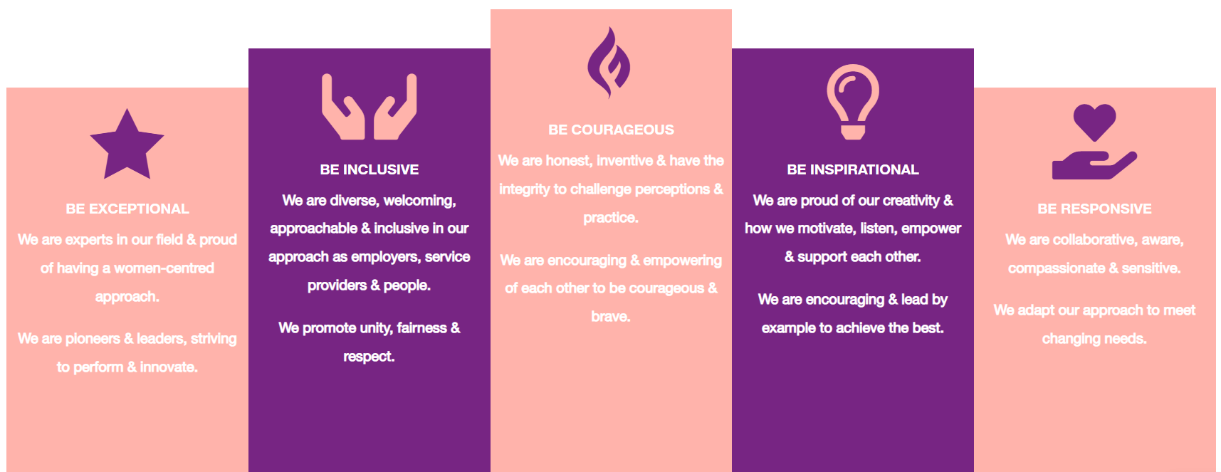

1. Be Exceptional
• We are experts in our field & proud of having a women-centred approach
• We are pioneers & leaders, striving to perform & innovate

2. Be Courageous
• We are honest, inventive & have the integrity to challenge perceptions & practice
• We are encouraging & empowering of each other to be courageous & brave

3. Be Inclusive
• We are diverse, welcoming, approachable & inclusive in as employers, service providers & people
• We promote unity, fairness & respect

4. Be Inspirational
• We are proud of our creativity & how we motivate, listen, empower & support each other
• We are encouraging & lead by example to achieve the best

5. Be Responsive
• We are collaborative, aware, compassionate & sensitive
• We adapt our approach to meet changing needs

