

Job Title | Sanctuary Support Team Leader – Female*
Salary | £34, 441
Responsible to | Operations Manager (Community)
Hours | 35 per week
Contract | Temporary – Maternity Cover

*This post will be subject to an enhanced DBS check and there is an Occupational Requirement under the Equality Act 2010 Schedule 9 (Part 1) for the post holder to be a woman. This post will be subject to an enhanced DBS check.
Leeds Women’s Aid (LWA) is the largest women’s charity in Leeds, and has been providing support to women and children affected by domestic abuse for over 50 years. We are committed to our values and strive to embody them in everything we do. We provide a range of the very best services for vulnerable women and families who are victims and survivors of domestic, sexual & honour- based violence and abuse, forced marriage and stalking.
LWA is the lead agency for commissioned Leeds Domestic Violence Service (LDVS), a consortium of three agencies offering support to women, men and transgender/non- binary people. This service works within a multi-agency framework providing a high quality, pro-active service to victims of domestic, sexual and honour- based violence and abuse, stalking and forced marriage, often to those at the highest risk.

LWA is also the lead agency in the innovative and unique National Lottery Community Fund funded Women and Girls Alliance, consisting of 11 women’s and girls’ organisations. Working with vulnerable women and girls, our vision is that many more women and girls in Leeds will have their needs met and be empowered to lead safer and healthier lives.

Purpose of Job

The Sanctuary Support Team (SST) was created in response to the Domestic Abuse Act 2021, that identified victim-survivors should be offered support if they live in ‘safe accommodation’. SST works alongside Leeds Housing Options (LHO), who manage the city’s sanctuary scheme and offers support to victim survivor’s once sanctuary installation has been completed by LHO.

SST is a city-wide consortium led by Leeds Domestic Violence Service, offering specialist domestic abuse support to victim-survivors. The team has SST Support Workers based within our partner organisations across Leeds which include Behind Closed Doors, Women’s Health Matters, Karma Nirvana, Shantona, PAFRAS, Age UK Leeds and Asha Neighbourhood Project. Having support workers in community spaces means that victim-survivors are able to work with individuals who understand the complex and different barriers that may impact different people from different backgrounds. This also means there is a breadth of knowledge, understanding and expertise they are able to use to not only to support victim survivors but that they are able to share with one another when working as a team.

Primarily, SST provides support to victim-survivors of domestic abuse living in properties that have been safer through a sanctuary installation by LHO. However, there are exceptions to this, for victim-survivors who may have no recourse to public funds or that are fleeing honour based abuse. SST workers are line managed and supported by their own organisation, but there is a matrix management arrangement in place with the SST Team Leader who leads on case management.

Physical Conditions
The Sanctuary Support Team Leader will be managed by the Operations Manager (Community) and the post is co-located with Leeds Housing Options (LHO) with their Domestic Abuse Team. The post holder will be also required to work from LWA’s main office on occasion, with some time spent at SST partner organisations.

Economic Conditions
This is a full-time post with a salary of £34,441.
Responsibilities
Responsible to:

The Sanctuary Support Team Leader is line managed by, and responsible to, the Operations Manager (Community) who reports to the Operations Director. All paid members of staff are accountable to the Chief Executive, and ultimately the Trustees of Leeds Women’s Aid, and will work according to policies and procedures agreed by them.

Responsible for:

Matrix management (alongside line managers from partner organisations) of:
- SST Support Workers located in different organisations across Leeds – this includes undertaking regular case reviews and having joint meetings with SST Support Workers and their line managers

And close liaison with;
- Line managers of the SST Support Workers
- Leeds Housing Options staff

Main Duties

- To be responsible for the effective delivery of the Sanctuary Support Team, ensuring the safety of victim-survivors is central to all processes.

- To ensure a consistent high-quality trauma-informed delivery of services to victim-survivors including case reviews, risk assessment, personal support and safety planning.

- To triage referrals and allocate cases to the Sanctuary Support Team taking into consideration the experience and expertise of staff and the level of complexity and risk.

- To manage and contact sanctuary referrals completed by LDVS colleagues, agreeing measures and working in partnership with LHO.

- To ensure appropriate and effective support and supervision for SST Support Workers including;
- Case reviews
- Joint meetings with the SST Support Workers and their line manager,
to ensure wellbeing and identifying learning and development needs and
performance management issues as necessary
- Regular team meetings

- To represent the service at operational and strategic multi-agency meetings developing and building relationships with key partner agencies.

- To ensure that any safeguarding concerns are identified, recorded, and managed promptly and appropriately in accordance with the SST Support Workers’ organisational safeguarding policies, procedures, and relevant legislation, always prioritising the safety and wellbeing of victim-survivors.

- To support with the induction and training of newly recruited staff within the Sanctuary Support Team, ensuring they are equipped with the knowledge, skills, and support necessary to deliver a high-quality service.

- To have the confidence to be able to professionally challenge other internal and external organisations when appropriate.

- To ensure case files and records are accurate and complete, and that both are kept in compliance with data protection legislation.

- To be responsible for the collation of service user feedback and to ensure this is used to continually improve the service and working practices.

- To ensure the Sanctuary Support Team provides a service which recognises the diverse needs of victim-survivors ensuring the service is accessible to all.

- To provide support and guidance to other LWA/LDVS staff to develop their skills, understanding and awareness of supporting victims-survivors who have experienced domestic abuse.

- To provide support and guidance to other LWA/LDVS staff to develop their skills, understanding and awareness of supporting victims-survivors who have experienced domestic abuse.

- To provide support and guidance to other organisations with SST staff to develop their skills, understanding and awareness of supporting victims-survivors who have experienced domestic abuse.

- To work with the Impact and Performance Manager, external funders and commissioners compiling and contributing to performance reports to ensure the service runs effectively and monitoring is accurate.

- To attend events and deliver training to promote the LDVS service.

- To ensure that all LWA and LDVS policies and procedures are implemented and promoted by staff.

General

- To attend staff meetings and other training events as required.

- To uphold LWA's policies, with particular reference to confidentiality, health and
safety and equity, diversity and inclusion.

- To carry out any other duties or training commensurate with the post.

- To carry out any other duties that are reasonably required by LWA

Person Specification

Experience | How Assessed:  C = Covering Letter  I = Interview
- Working in a role supporting victims of domestic, sexual and honour based violence and abuse, stalking and forced marriage completing risk assessments, support plans and safety plans | C/I
- Leading a team within a fast-paced working environment | C/I
- Monitoring and performance management | C/I
- Working within a legislative framework | I
- Working within an operational multi-agency environment, attending meetings and developing and influencing partnership working | C/I
Understanding
- Violence against women and domestic, sexual and honour- based violence and abuse, stalking and forced marriage. | C/I
- Housing related legislation including statutory roles and responsibilities | I
- Child protection and adult safeguarding issues and procedures | C/I
- Trauma-informed approaches and the impact of trauma on victim-survivors and their children | I
- Risk assessments, safety planning, care pathways and best practice when working with high risk victim-survivors | C/I
- Criminal justice system and legal processes including the legal and practical remedies available to victim-survivors | I
- DRAM, MARAC, MAPPA and Domestic Abuse Disclosure Scheme | C/I
- Multi-agency partnerships and other voluntary and statutory services involved in the response to domestic abuse | C
- The ‘whole family approach’ and ‘asset-based’ ways of working | C
Skills
- Leading, motivating and supporting teams using mentoring and coaching skills when required | C/I
- Excellent crisis management skills and the ability to deal with stressful and difficult situations under pressure | C/I
- Excellent IT skills and be able to present complex information clearly | C
Qualifications/ Professional Membership
- SafeLives IDVA training qualification or equivalent (desirable) | C
- Management or leadership qualification (desirable) | C
Personal Qualities
- To have values in line with those of LWA | I
- To act with integrity and respect when interacting with service users, employees, agencies and individuals | C
- To be committed to upholding LWA’s policies and procedures | C
- To be committed to diversity and working in an anti- discriminatory way | C
LWA’s Values

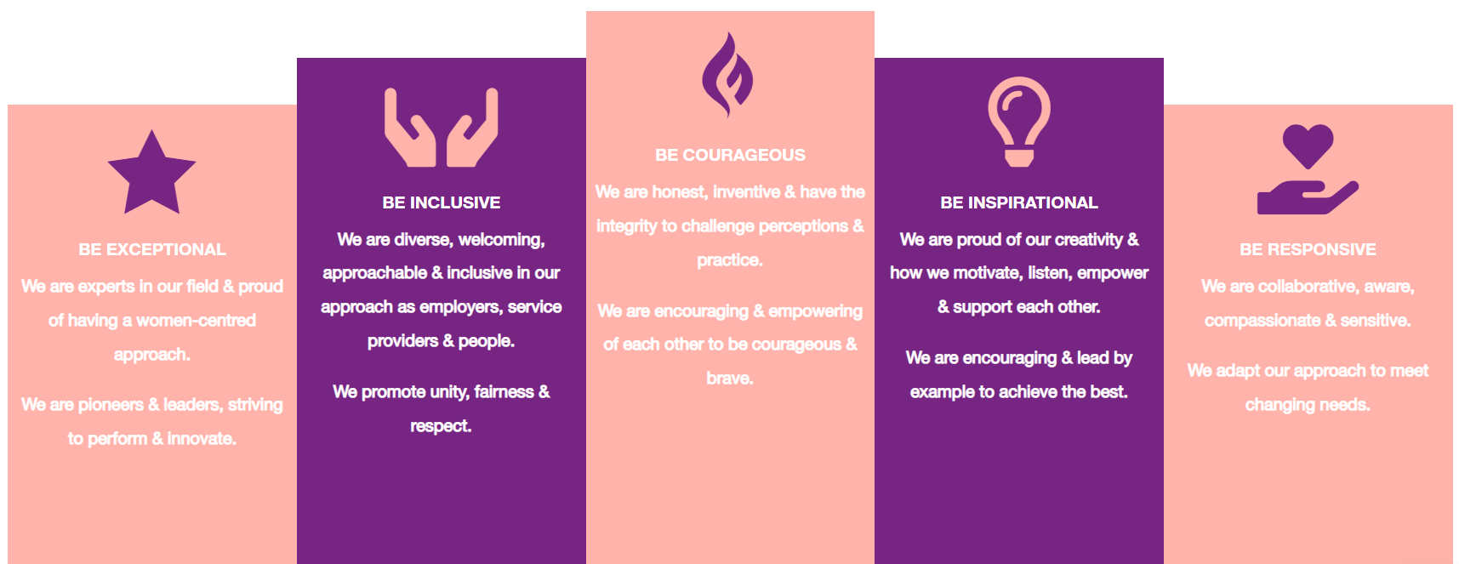

Be Exceptional
  - We are experts in our field & proud of having a women-centered approach
  - We are pioneers & leaders, striving to perform & innovate

Be Courageous
  - We are honest, inventive & have the integrity to challenge perceptions & practice
  - We are encouraging & empowering of each other to be courageous & brave

Be Inclusive
  - We are diverse, welcoming, approachable & inclusive in as employers, service providers & people
  - We promote unity, fairness & respect

Be Inspirational
  - We are proud of our creativity & how we motivate, listen, empower & support each other
  - We are encouraging & lead by example to achieve the best

Be Responsive
  - We are collaborative, aware, compassionate & sensitive
  - We adapt our approach to meet changing need

