Children’s Support Worker
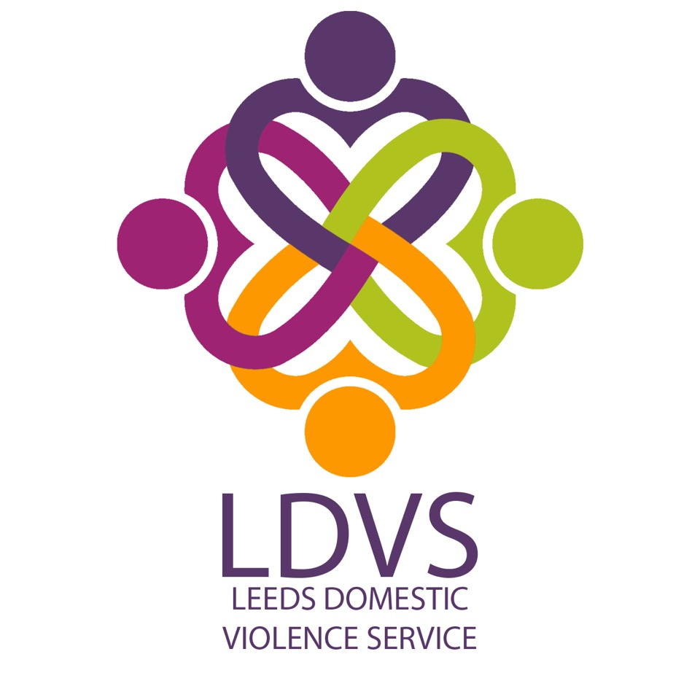

Understanding
You are required to have an excellent understanding of:

- Violence against women; and domestic, sexual and honour based violence and abuse, stalking and forced marriage;
- The impact on victims and their children.
- Knowledge of vulnerable children/young people, their emotions and behaviours.
- Services across Leeds to support vulnerable Children and Young People.
- Safeguarding Children and Young People.
- Stages of Child Development.
- Signs and symptoms of abuse and neglect.

Experience
You are required to have experience of:

- Recording and reviewing detailed information;
- Assessing the needs of children and young people.
- Advocating on behalf of children and young people
- Working with other voluntary and statutory services involved in the response to domestic violence and abuse;
- Managing a high volume caseload.
- Facilitating age appropriate activities for children and Young people.
- Identifying/ reporting of Child protection issues.

Skills
You are required to be able to demonstrate that you have:

- Excellent crisis management skills and the ability to deal with stressful and difficult situations;
- Excellent interpersonal skills;
- Good technological skills, including the ability to use electronic databases and software, and being able to present information clearly.
- The ability to work in multi agency and refuge teams to ensure you get the best outcome for the child/ young person/ family.

Qualifications/ Professional Membership
You are required to:

- Hold a Children and/ or Young Peoples qualification. e.g NVQ, NNEB, Social Care Degree

Personal Qualities

You are required to be able to demonstrate your ability to:

- Be flexible and willing to work in all types of statutory and voluntary sector environments, including multi agency settings;
- Interact with children and young people at their own level.
- Act with integrity and respect when interacting with clients, employees, agencies and individuals;
- Show initiative in working with other agencies

Values
- Values must be consistent with those of LWA i.e. non-judgemental and the ability to maintain confidentiality.
- Commitment to upholding LWA’s policies and procedures.
- Commitment to diversity and working in an anti-discriminatory way.
- Willingness to work flexibly.

