IDVA Person Specification
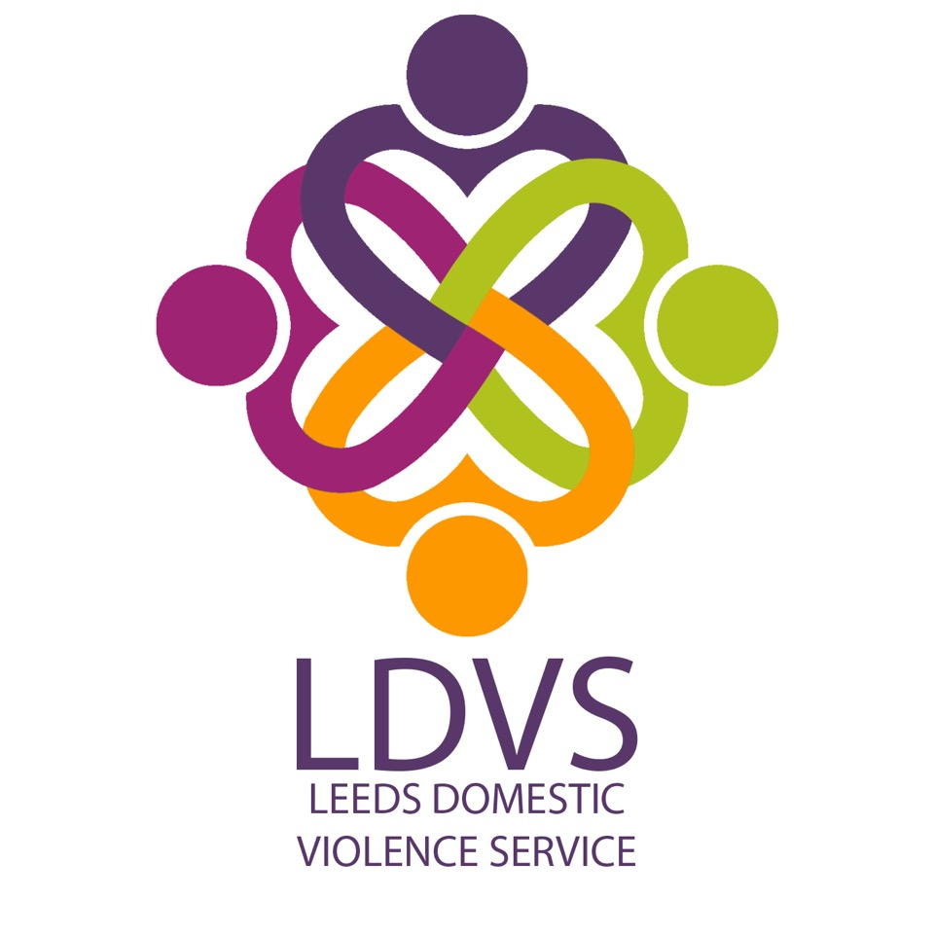

Understanding
You are required to have an excellent understanding of:

- Violence against women; and domestic, sexual and honour based violence and abuse, stalking and forced marriage; (A&I)
- The impact on victims and their children; (A&I)
- The legal and practical remedies available to these clients; (A&I)
- IDVA work including risk assessments, safety planning, care pathway and best practice when working with high risk victims ; (A&I)
- Multi-agency partnerships and information sharing in domestic violence cases; (I)
- Safeguarding issues in relation to children & young people and vulnerable adults. (A&I)

Experience
You are required to have experience of:

- Working as an IDVA, or directly with IDVAs, in working with victims of domestic, sexual and honour based violence and abuse, stalking and forced marriage; (A)
- In-depth telephone and face to face advice work; (A)
- Recording, tasking and reviewing detailed information; (A&I)
- Assessing the needs of clients & working with High Risk victims; (I)
- Advocating on behalf of clients; (I)
- Working with other voluntary and statutory services involved in the response to domestic violence and abuse; (A)
- Managing a high volume caseload. (A&I)

Skills
You are required to be able to demonstrate that you have:

- Excellent crisis management skills and the ability to deal with stressful and difficult situations; (I)
- Excellent interpersonal skills; (I)
- Good technological skills, including the ability to use electronic databases and software, and being able to present information clearly. (A&I)

Qualifications/ Professional Membership
You are required to:

- Hold a SafeLives (CAADA) IDVA training qualification, or equivalent, or have substantial equivalent experience. (A)

Personal Qualities and Values
You are required to be able to demonstrate your ability to:

- Be flexible and willing to work in all types of statutory and voluntary sector environments, including multi agency settings; (I)
- Act with integrity and respect when interacting with clients, employees, agencies and individuals; (I)
- Show initiative in working with other agencies (I)

- Values must be consistent with those of LWA i.e. non-judgemental and the ability to maintain confidentiality. (I)
- Commitment to upholding LWA’s policies and procedures. (I)
- Commitment to diversity and working in an anti-discriminatory way. (A&I)
- Willingness to work flexibly. (A)

