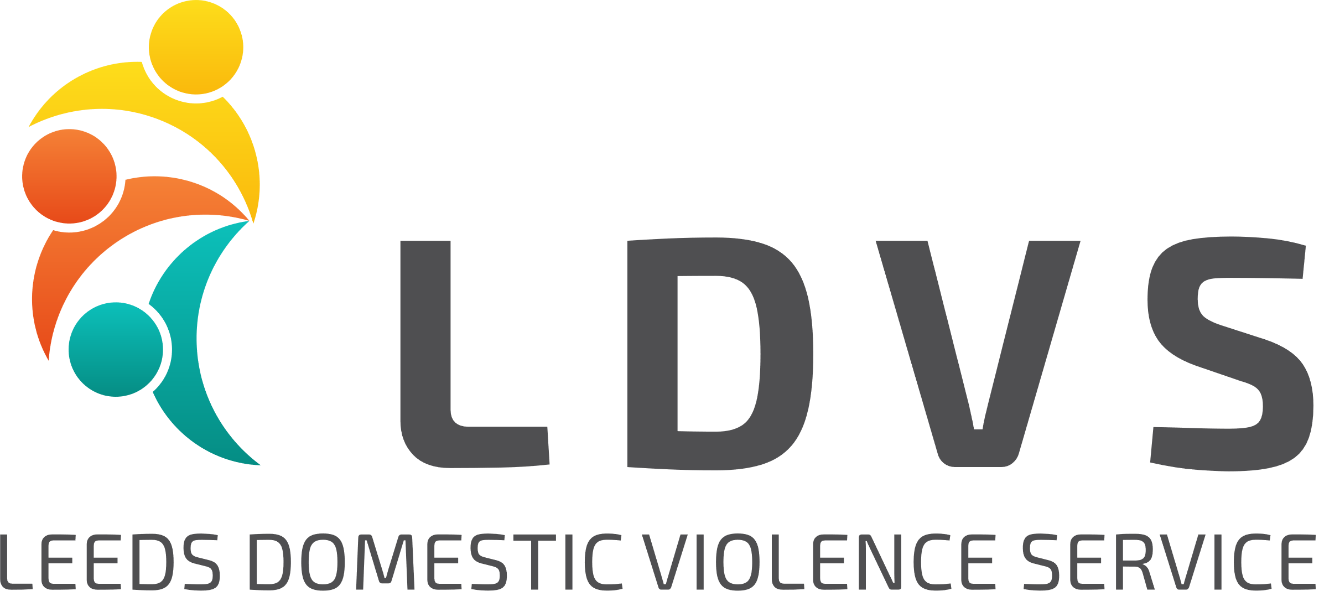

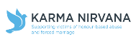
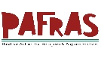
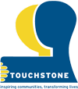
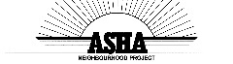
Sanctuary Support Workers
3 X 21 hours per week*
(*The post with Karma Nirvana has the potential to extend to 37.5 hours per week)
£24,000p.a. (pro-rata)
We are looking for a team of experienced and committed workers who will provide support for individuals and families who need ‘sanctuary’ to keep them safe from Domestic Violence and Abuse. Sanctuary is provided by Leeds City Council and consists of safety and security measures to help people stay safe in their homes. There are 8 posts in total in a consortium led by Leeds Women’s Aid and employed by Leeds Domestic Violence Service partner organisations.
We are currently recruiting for Asha Neighbourhood Project, Karma Nirvana and Touchstone. The posts will be based with the partner organisations located across the city who will work closely together as a team to deliver support and safer housing for people and families recovering from Domestic Violence and Abuse.
This is an exciting opportunity for the right people to join an exciting and innovative new multi-agency service. You will be reaching out to people who may not be aware of the support available in Leeds for anyone experiencing domestic violence and abuse. Be part of this team helping people to get the right support!
You will need:
- Experience of working with vulnerable adults and children
- An excellent understanding of Domestic Violence and Abuse and the impact on individuals, families and children
- A commitment to diversity and working in an anti-discriminatory way
For more detailed information about these posts, where they will be based, how to apply and to download the application pack please go to the Leeds Women’s Aid web site: http://www.leedswomensaid.co.uk/join-our-team/
Closing date for applications: 9am on Friday 10th of December, 2021
Interviews to be held: Week beginning 13th December, 2021
For an informal conversation about these posts please contact the Sanctuary Support Team Leader – Lucy Johns on lucyj@ldvs.uk
These posts have been funded through New Burdens funding through Leeds City Council
Each organisation is committed to Equal Opportunities and Managing Diversity and welcome all applications.
Registered Charity No.1005884 Company Limited by Guarantee No. 2627468

