**Leeds Women’s Aid’s Big Give Women and Girls Match Fund – Resource Pack**

Thank you for supporting Leeds Women’s Aid’s fundraising appeal with the Big Give’s Women and Girls Match Fund. Below are graphics you can save and use, and social media captions you can copy and paste to help spread the word.

**Email Signature:**

You can save and insert the graphic into your work or personal email signature.

You can link the graphic to our Big Give page by right clicking it when you insert it and pasting the appeal page address into the search box: <https://donate.biggive.org/campaign/a05WS000005IwU5YAK>

Please ensure to also include the link underneath the graphic, you can copy and paste the below:

**Leeds Women’s Aid Big Give Appeal:** [**https://donate.biggive.org/campaign/a05WS000005IwU5YAK**](https://donate.biggive.org/campaign/a05WS000005IwU5YAK)

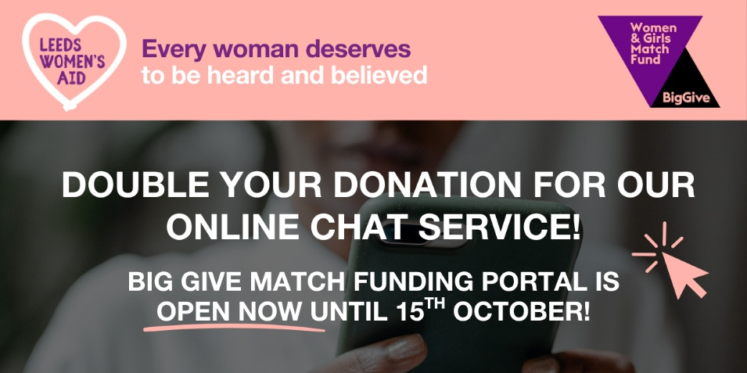

**Social Media Graphic:**

This graphic can be used on all social media posts with the accompanying captions for the different platforms below.

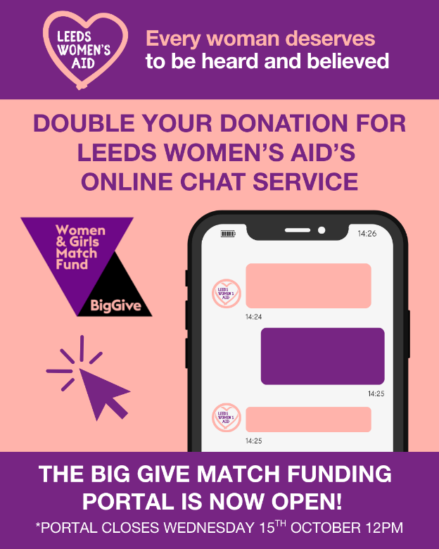

**Captions:**

**LinkedIn/Facebook:**

[I’m/we’re] supporting @LeedsWomensAid’s Big Give Women & Girls Match Fund Campaign, raising funds to keep their online chat service running - a safe and discreet way for women and girls across Leeds to access support.

The fundraising portal is now open! Every donation made through the portal between now and midday 15th October will be doubled, helping to sustain this vital service for those who can’t safely speak on the phone.

Make your donation and double your impact at: <https://donate.biggive.org/campaign/a05WS000005IwU5YAK>

#LeedsWomensAid #TheBigGive #WomenAndGirls #DomesticAbuseSupport #OnlineChatService

**Instagram:**

[I’m/we’re] supporting @LeedsWomensAid’s Big Give Women & Girls Match Fund Campaign to help keep their online chat service running — a safe and discreet way for women and girls across Leeds to access support.

The fundraising portal is now open! Every donation made through the portal between now and midday 15th October will be doubled, helping to sustain this vital service.

For many victim-survivors, making a phone call doesn’t feel safe. The online chat provides a lifeline, offering advice, safety planning and access to refuge when needed.

To make your donation and double your impact, head to the link in @LeedsWomensAid’s bio.

#LeedsWomensAid #TheBigGive #BigGiveMatchFund #WomenAndGirls #DomesticAbuseSupport #Leeds #LWA

**WhatsApp Message**

The following text can be shared with friends, family, and colleagues on WhatsApp or other group chats to help spread the word:

Hey, I wanted to share this with you. Leeds Women’s Aid is taking part in the Big Give Women & Girls Match Fund Campaign this October to raise funds for their online chat service — a safe and discreet way for women and girls in Leeds to get support.

Any donations made between midday 8th and midday 15th October will be doubled, so your gift makes twice the impact.

If you can, please donate or share the link with others:  
<https://donate.biggive.org/campaign/a05WS000005IwU5YAK>